**PRACTICAL FILE**

**BE (CSE) 4th Semester**

**OPERATING SYSTEM**

**Jan 2024 – June 2024**

**Submitted By**

**Name: Jatin Dhiman**

**Roll Number: UE223047**

**Submitted To**

**Dr. Mamta Juneja**

**Professor, Computer Science and Engineering**



**Computer Science and Engineering**

**University Institute of Engineering and Technology**

**Panjab University, Chandigarh – 160014, INDIA**

**2024**

  INDEX

|  |  |  |  |
| --- | --- | --- | --- |
| S.NO | PRACTICAL | DATE | PAGE NO |
| 1 | 1. Introduction to Operating System,    Types of Operating System, Difference between Linux,Unix and Windows 2. Installation of Ubuntu | 18/01/2024 |  |
| 2 | To implement the commands:  cat,man,echo,touch,ls,mkdir,cd,cp, pwd,tty,who,wc,mv, rmdir,rm,script | 25/01/2024 |  |
| 3 | To implement the commands:  whatis , whereis,find,type,bc,expr, diff,cmp,comm,sort,tee,cut,tr, grep,head,tail,free,df,du,ulimit, cal,ncal,pipe(|) | 01/02/2024 |  |
| 4 | To implement the commands:  umask , chmod, adduser,su, deluser,gzip/gunzip,tar, split,sleep,shutdown,chown,semicolon(;) | 08/02/2024 |  |
| 5 | To implement the commands:  ps,nohup,kill,nice,batch, crontab,wall,write | 15/02/2024 |  |
| 6 | Shell scripting  → Introduction to vim editor  → Syntax of control structure | 22/02/2024 |  |
| 7 | Programs:   * Addition of two numbers * Check whether the number entered is odd/even * Check whether the year is leap or not * Calculate the average salaries of employees * Calculate the average marks of students * To find circumference and area of circle * To find the sum of digits of a number. * Find the factorial of a number * Find the fibonacci series * Check whether a number is prime or not * Check whether the number is palindrome or not * Reverse of a given number * To create a binary calculator using switch case * Linear Search * Binary search * Bubble sort | 29/02/2024 |  |
| 8. | To implement the following String Operations programs in vim editor:  i) Find length of string  ii) Compare two strings  iii) Reverse of a string  iv) String is palindrome or not  v) Occurrence of a pattern  vi)Concatenate strings  vii) Convert lowercase letters into uppercase. | 07/03/2024 |  |
| 9. | To implement the following File Operations programs in vim editor :  i) To see permissions of a file after checking whether it is file or directory  ii) Rename file  iii) Take backup of a directory  iv) Compare directories and delete duplicate files  v) To check the number of files through command  line arguments  vi) If number of files is even, then copy first argument in second and so on, else display odd  vii) Number of arguments.  viii) Convert lowercase letters into uppercase.  ix) To calculate length of a file | 14/03/2024 |  |
| 10 | Write a C++ program to implement the following CPU scheduling algorithms :   * First Come First Serve(FCFS) * Shortest Job First(SJF) (P, NP) * Priority Scheduling (P, NP) * Round Robin(RR) | 21/03/2024 |  |
| 11 | C++ programming to implement Banker’s Algorithm:   * Safety Algorithm- * Request and Resource Allocation |  |  |
| 12 | Write a C++ program to implement the following Process  synchronisation algorithms with semaphores :   * Producer Consumer Problem * Reader Writers Problem * Dining Philosopher Problem |  |  |
| 13 | C++ programming to implement Page Faults:   * FIFO page replacement * Optimal Page Replacement (OPR) * Least Recently Used(LRU) * Most Frequently Used(MFU) * Least Frequently Used(LFU) |  |  |
| 14 | Write C++ programs to implement Disk Scheduling Algorithm:   * FCFS * SSTF * SCAN * C-SCAN * LOOK * C-LOOK |  |  |
| 15 | Write C++ programs to implement the following Memory management algorithms (MVT) :     * First Fit (FF) * Best Fit (BF) * Worst Fit (WF) |  |  |

**Practical:- 1**

**Introduction and Installation**

**Operating System**

An OS is a collection of s/w programs. It mainly controls the allocation and usage of h/w resources such as memory, CPU time, hard disk space etc.

All application programs use the OS to gain access to these hardware resources as and when they are needed. The OS is the 1st program to be loaded into the computer when it boots & it remains in memory at all times thereafter.

**Types of Operating System**

* **Single user OS** – this OS supports 1 user at a time. The user can perform one task as well as multiple tasks on the OS. For ex, MS – DOS, MS – Windows
* **Multi user OS** – in this OS, multiple users can execute single task or multiple tasks at any given point of time. For ex, UNIX, LINUX, Windows Server OS

**Installation Process**

**Setup for UBUNTU**

Step 1:

First, open VirtualBox, then click "New" to create a virtual machine.

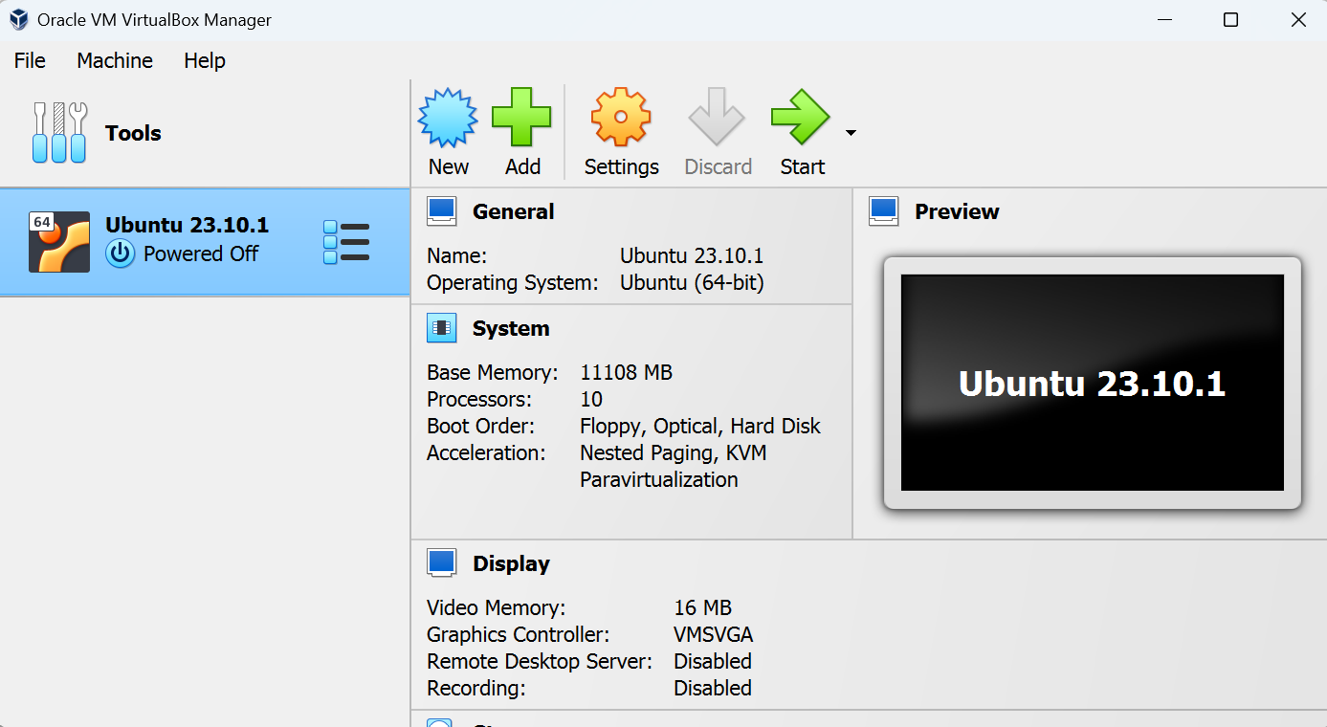

Step 2:

Enter "Ubuntu 23.10.1" as the name, select "Linux" as the type, and select Ubuntu (64-bit) as the version.

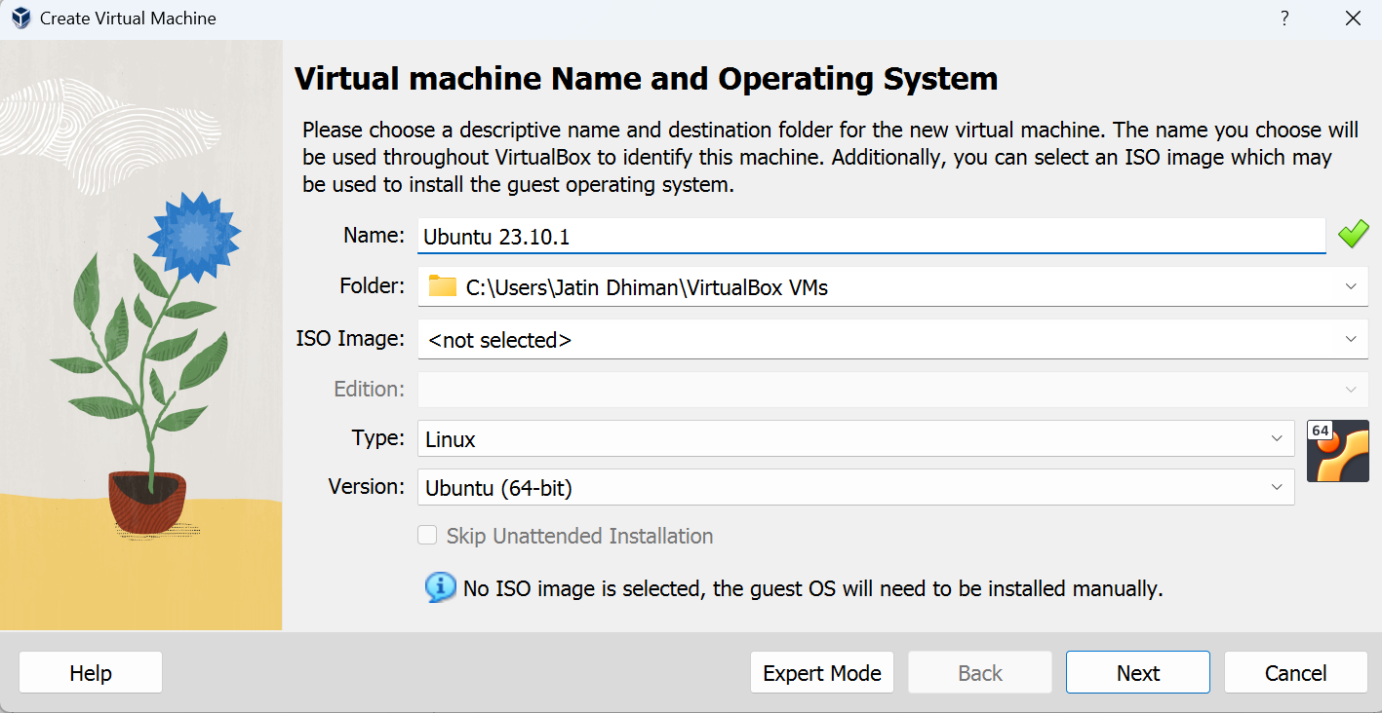

Step 3:

Select Base Memory and Processors

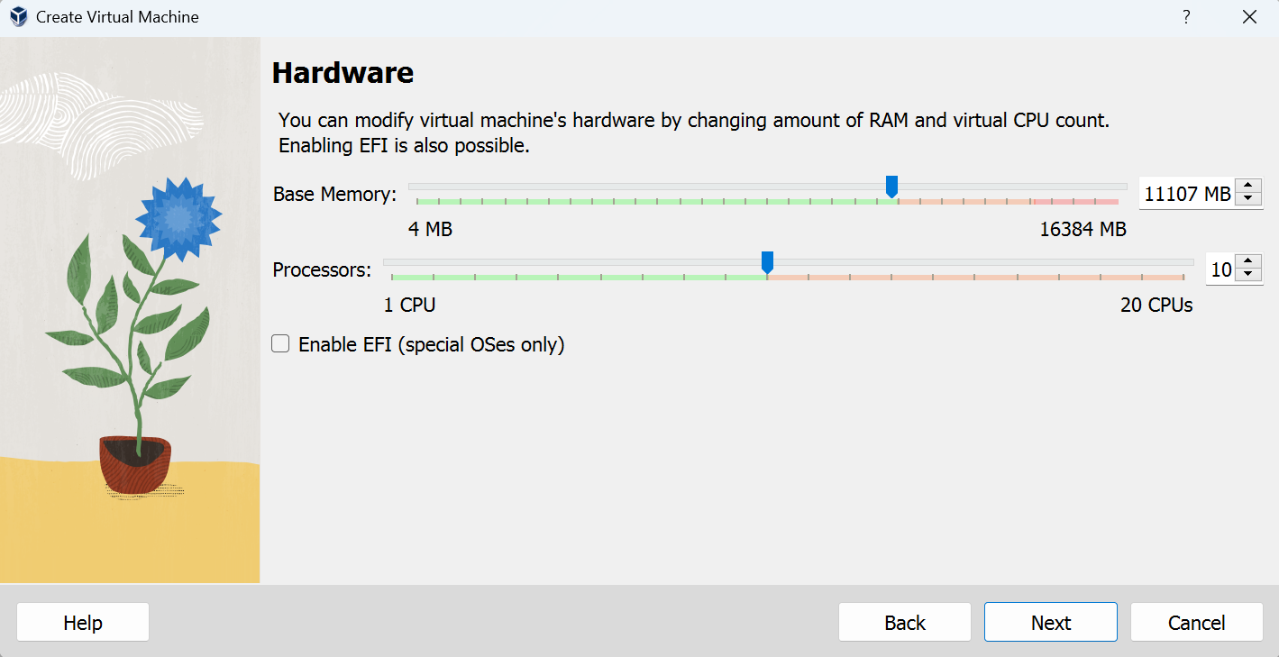

Step 4:

Create a Virtual hard disk, will see UBUNTU on dashboard.

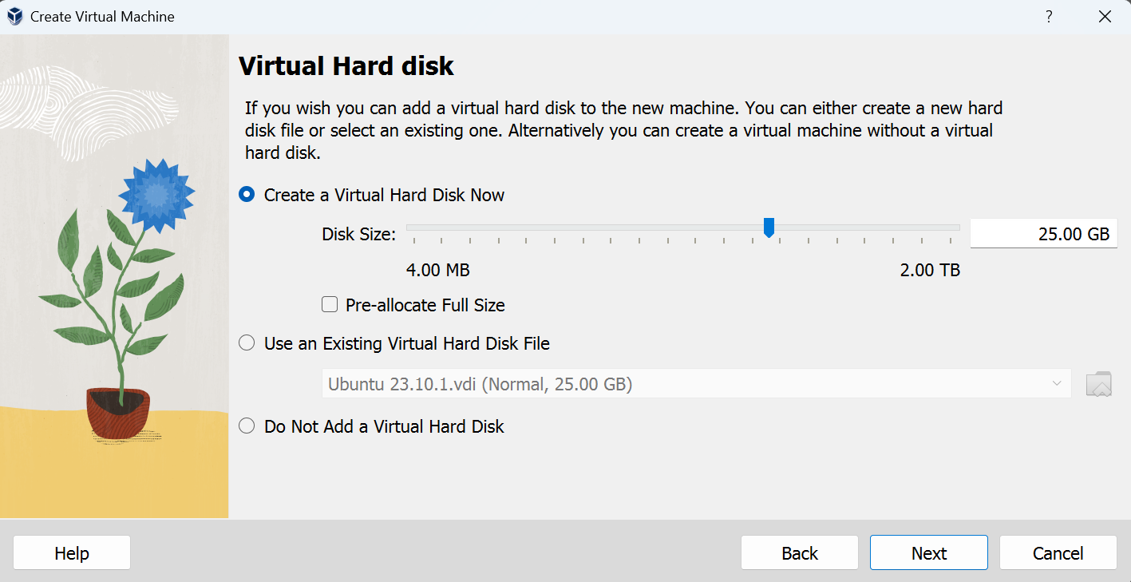

Step 5:

Summary of the Setup will be shown. Finish it!

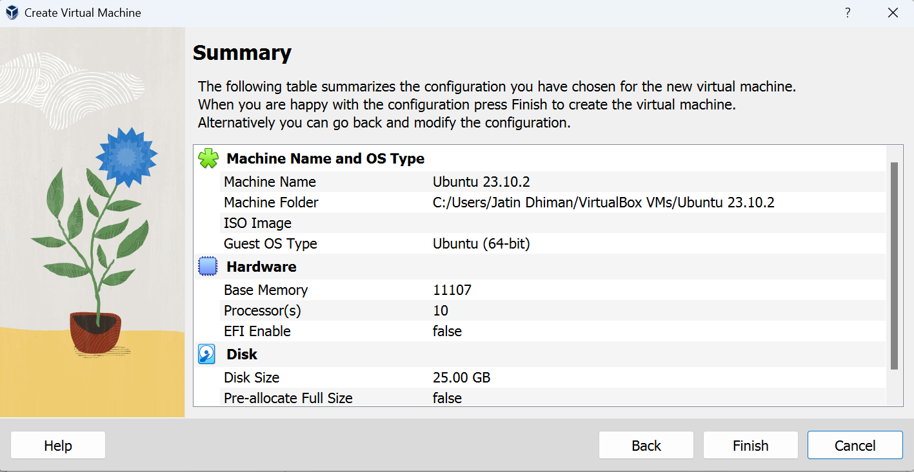

Step 6:

Select iso file in storage section in settings as follows.

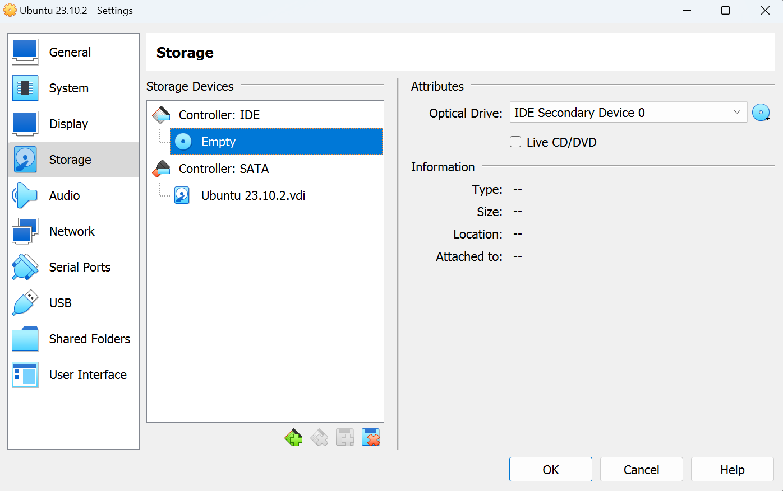

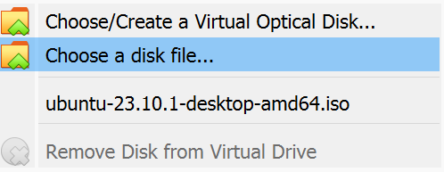

Step 7:

Your Ubuntu OS is ready to install in VirtualBox. Let's start!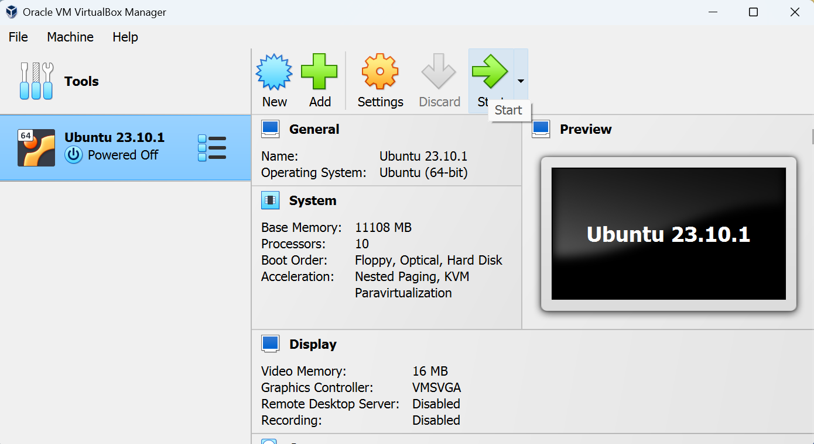

**Installing UBUNTU**

Step 1:

Click Install ubuntu

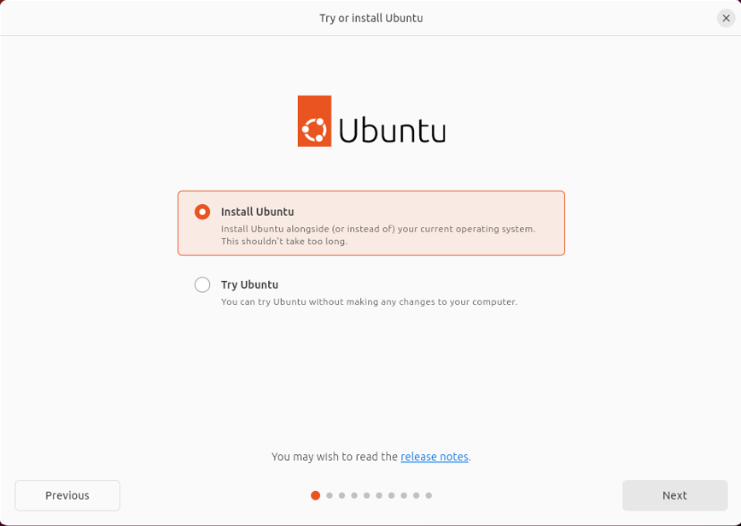

Step 2:

Select your keyboard layout.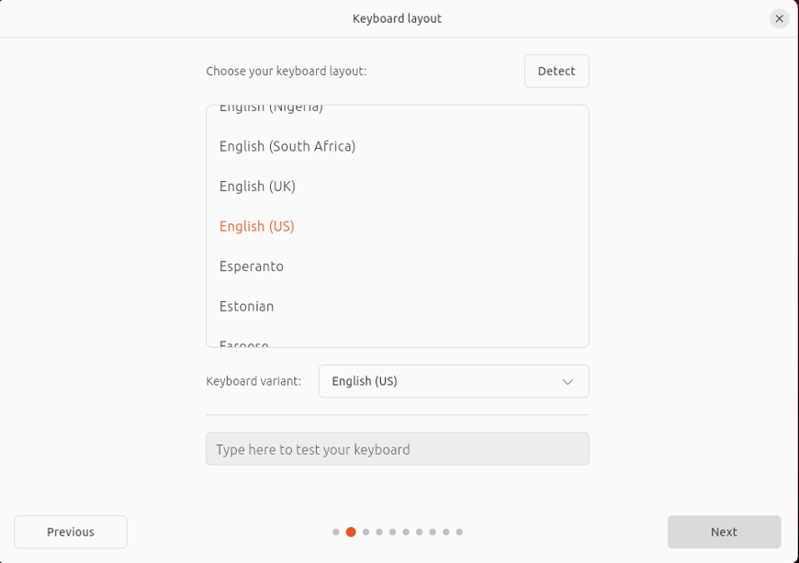

Step 3:

Select Default Installation



Step 4:

In "Installation type", check "Erase disk and install Ubuntu".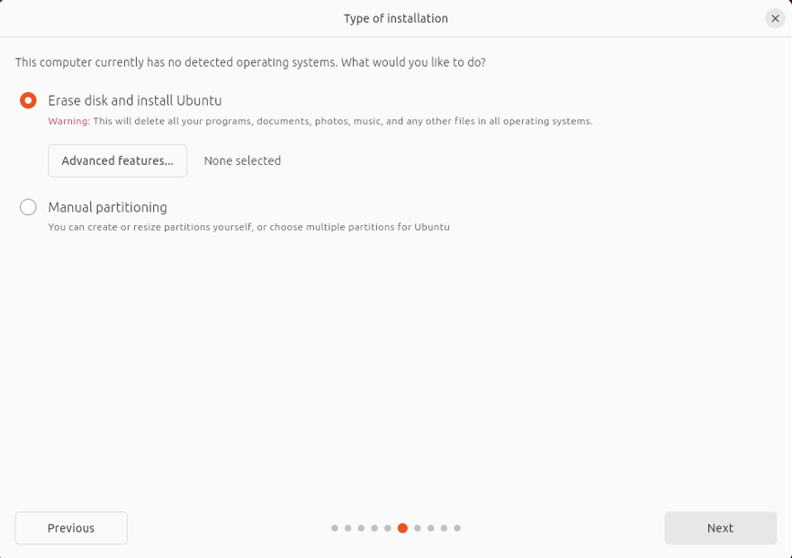

Step 5:

Ready to Install

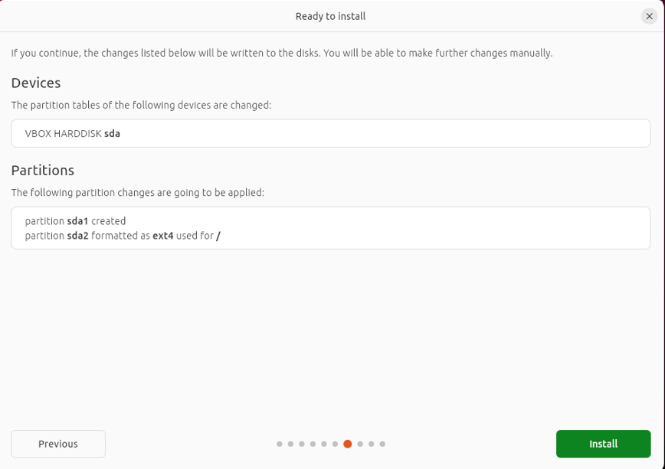

Step 6:

Set up your account

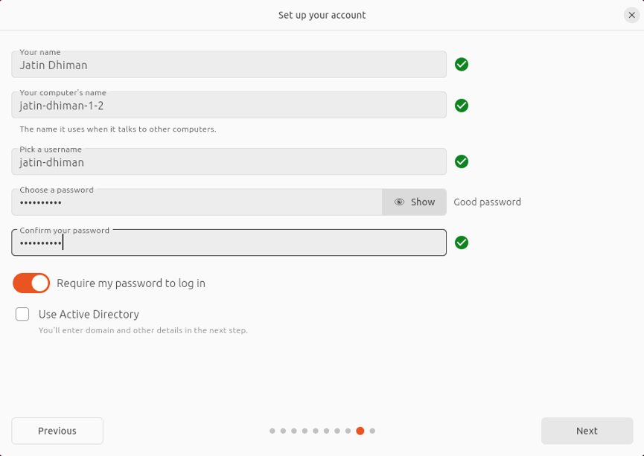

Step 7:

Choose your theme.

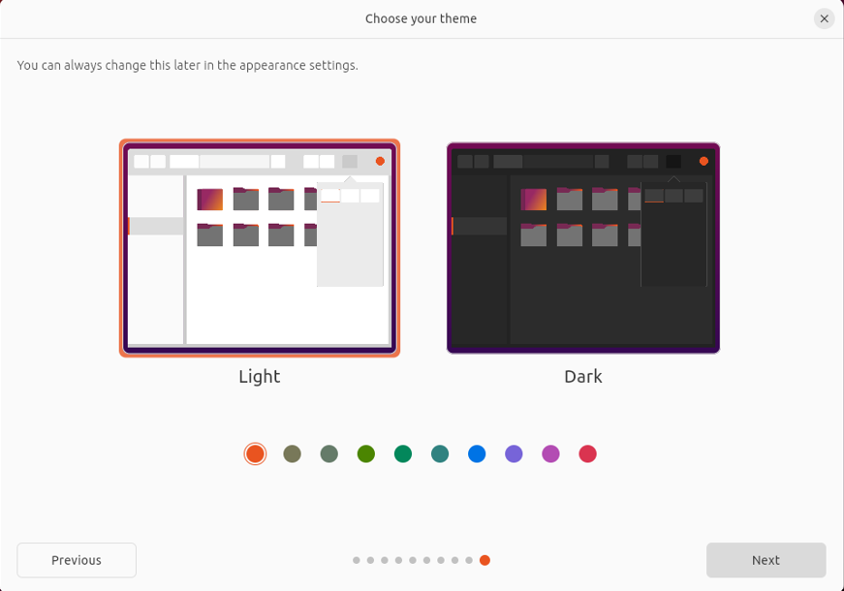

Step 8:

Copying and Installing ubuntu.

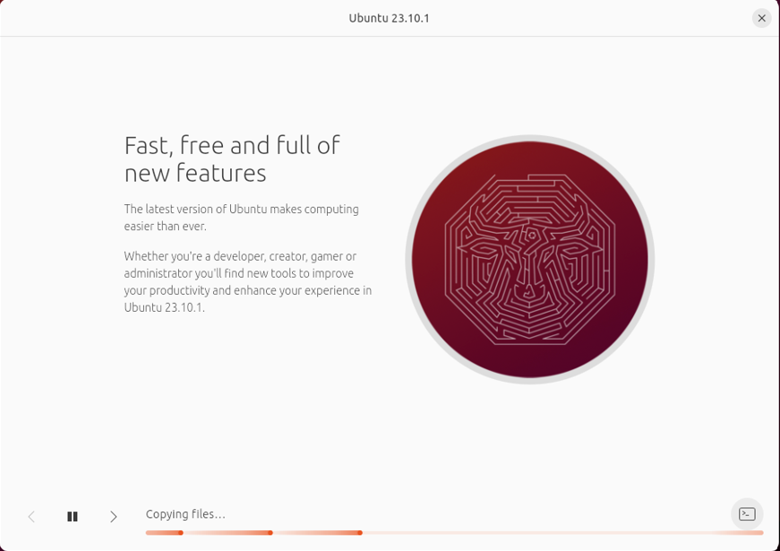

Step 9:

Restart your Virtual Machine.

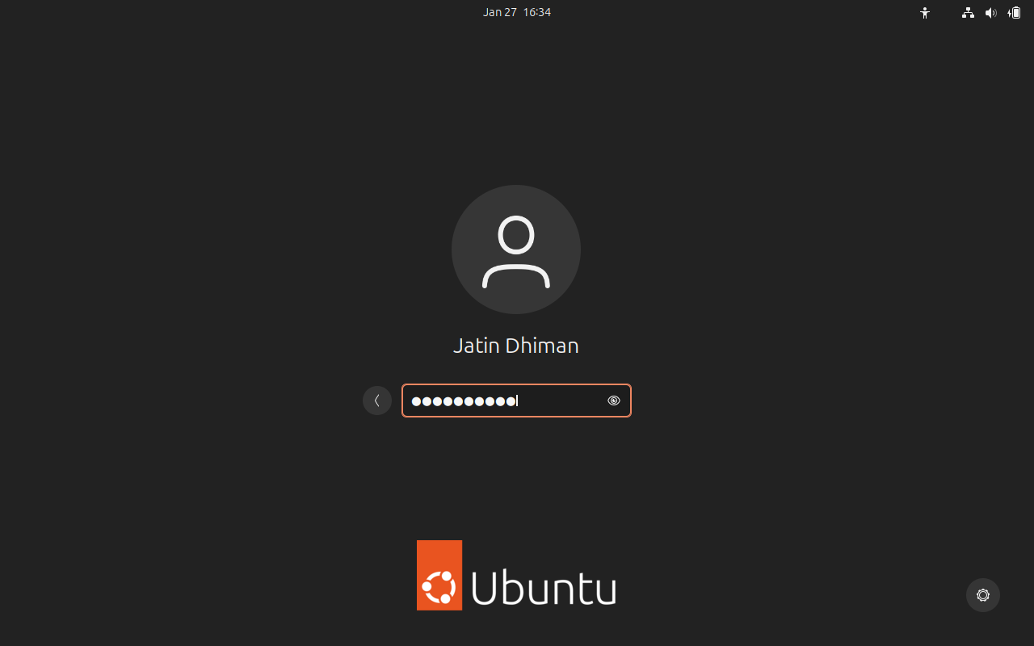

**Practical:- 2**

**Basic Commands**

1. **pwd Command (The Current Working Directory)**

To display the current working directory, we use the pwd (print working directory) command

When we first log in to our system (or start a terminal emulator session) our current working directory is set to our home directory. Each user account is given its own home directory and it is the only place a regular user is allowed to write files.

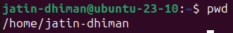

Pwd command is builtin as well as an external command

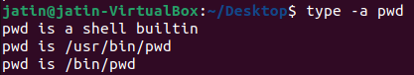

1. **cd Command (Changing the current working Directory)**

* To change your working directory we use the cd command.
* Absolute Pathnames

An absolute pathname begins with the root directory and follows the tree branch by branch until the path to the desired directory or file is completed.

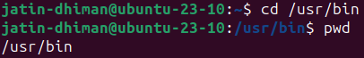

* Relative Pathnames

Where an absolute pathname starts from the root directory and leads to its destination, a relative pathname starts from the working directory

The "." symbol refers to the working directory and the ".." symbol refers to the working directory's parent directory.

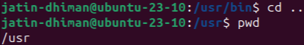

* Changing working directory from /usr to /usr/bin

Absolute pathnames

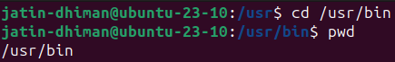

Relative pathnames

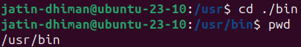

* **cd** Changes the working directory to your home directory

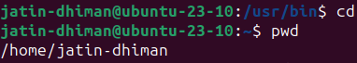

* **cd -** Changes the working directory to the previous working directory.

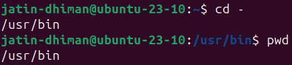

**COMMON OPTIONS IN cd COMMAND**

**-L :** If you tell cd to move into a "directory", which is actually a symbolic link to a directory, it moves into the directory the symbolic link points to.

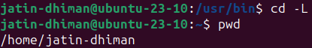

**-P :** Use the physical directory structure without following symbolic links. In other words, only change into the specified directory if it actually exists as named; symbolic links will not be followed. This option is the opposite of the -L option, and if they are both specified, this option will be ignored.



**-e** **:** If the -P option is specified, and the current working directory cannot be determined, this option tells cd to exit with an error. If -P is not specified along with this option, this option has no function

**-@ :** present a file with extended attributes as a directory containing the file attributes

1. **ls Command**

* To see a list of files and subdirectories contained in the current working directory.
* Besides the current working directory, we can specify the directory to list, like so:



* Or even specify multiple directories. In this,we will list both the user's home directory (symbolized by the “~” character) and the /usr directory

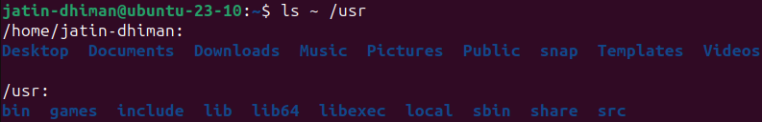

* We can also change the format of the output to reveal more detail, By adding “-l” to the command, we changed the output to the long format.

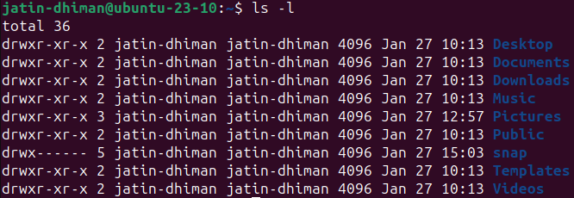

* Many commands allow multiple short options to be strung together. In this, the ls command is given two options, the “l” option to produce long format output, and the “t” option to sort the result by the file's modification time.

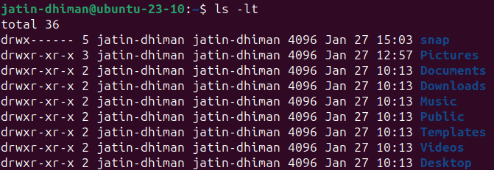

* We'll add the long option “--reverse” to reverse the order of the sort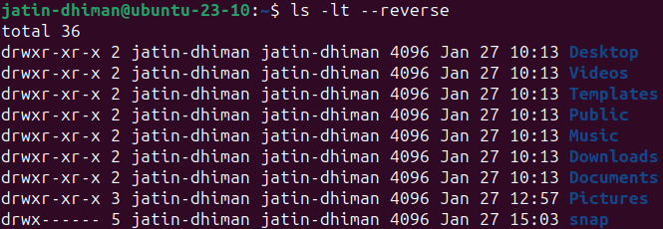

**COMMON OPTIONS IN ls COMMAND**

**-a** (--all) **:** List all files, even those with names that begin with a period, which are normally not listed (i.e., hidden).

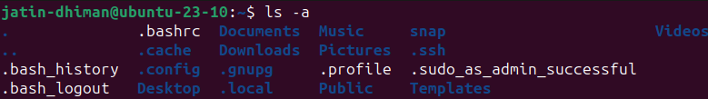**-A** (--almost-all) **:** Like the -a option above except it does not list . (current directory) and .. (parent directory).

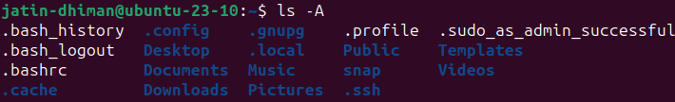**-d** (--directory) **:** Ordinarily, if a directory is specified, ls will list the contents of the directory, not the directory itself. Use this option in conjunction with the -l option to see details about the directory rather than its contents.

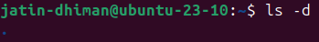

**-F** (--classify) **:** This option will append an indicator character to the end of each listed name. For example, a “/” if the name is a directory

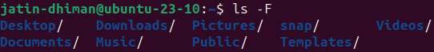

-**h** (--human-readable) **:** In long format listings, display file sizes in human readable format rather than in bytes

  
**-l :** Display results in long format

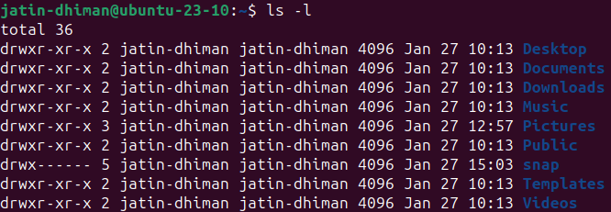**-r** (--reverse) **:** Display the results in reverse order. Normally, ls displays its results in ascending alphabetical order.

**-S :** Sort results by file size

**-t :** Sort by modification time

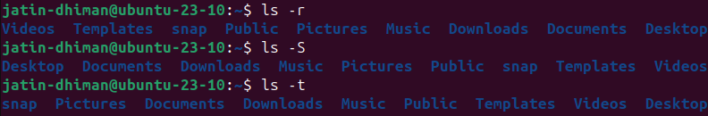

1. **mkdir Command**

* The mkdir command is used to create directories. It works like this:

mkdir directory...

* Would Create a Single directory named “dir1”



* Would Create three directories named “dir1”, “dir2”, and “dir3”



* Making Directory using brace expansion 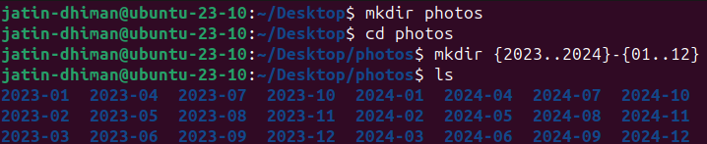
* Would Create three directories named “dir1”, “dir2”, and “dir3”

**COMMON OPTIONS IN mkdir COMMAND**

**-p :** parents or path, will also create all directories leading up to the given directory that do not exist already. For example, mkdir -p dir1/dir2 will create directory a if it doesn't exist, then will create directory b inside directory a. If the given directory already exists, ignore the error.





1. **touch Command**

* You can create an empty file using the touch command:



* If the file already exists, it opens the file in write mode, and the timestamp of the file is updated.
* The Command below creates three empty files at once using the touch command and you can create as many files you like.

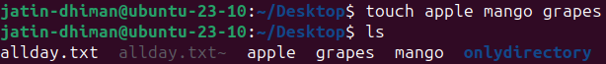

**COMMON OPTIONS IN touch COMMAND**

**-a :** This command is used to change access time only. To change or update the last access or modification times of a file touch -a command is used.

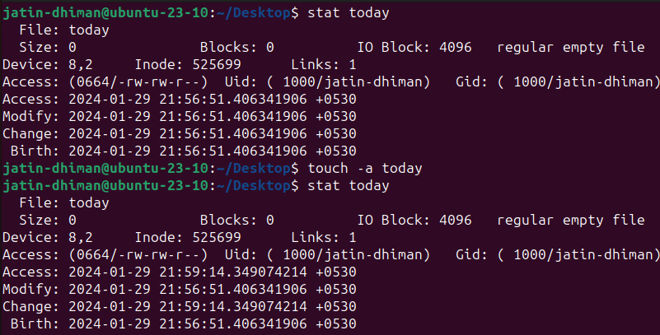

**-c :** This command is used to check whether a file is created or not. If not created then don’t create it. This command avoids creating files. Here, we wanted to create file 'movie' but with 'c' option no file has been created

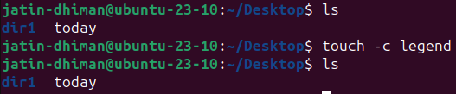

**-m :** This is used to change the modification time only. It only updates last modification time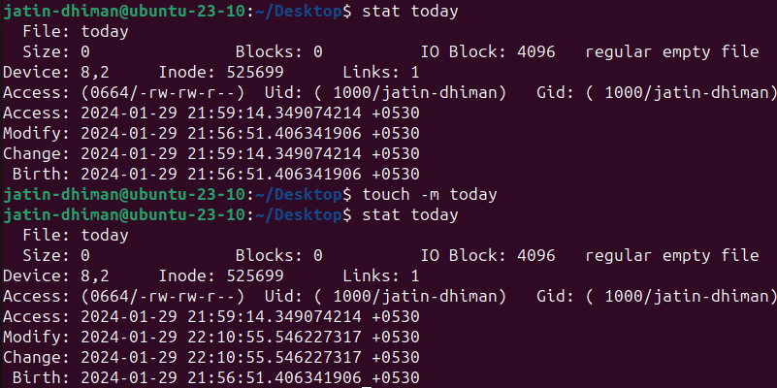

1. **man Command**

* It is used to display the user manual of any command that we can run on the terminal. It provides a detailed view of the command which includes NAME, SYNOPSIS, DESCRIPTION, OPTIONS, EXIT STATUS, RETURNVALUES, ERRORS, FILES, VERSIONS, EXAMPLES, AUTHORS and SEE ALSO.
* **Section** **Contains**

1 User Commands

2 System Calls

3 C Library Functions

4 Devices and Special Files

5 File Formats and Conventions

6 Games

7 Miscellaneous

8 System Administration

* Most executable programs intended for command line use provide a formal piece of doc umentation called a manual or man page. A special paging program called man is used to view them. It is used like this:



* man command didn’t work for cd

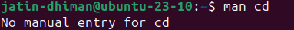

**COMMON OPTIONS IN man COMMAND**

**-k :** This option searches the given command as a regular expression in all the manuals and it returns the manual pages with the section number in which it is found.

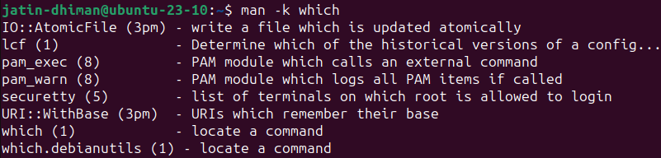

Using man Command to Learn a New command

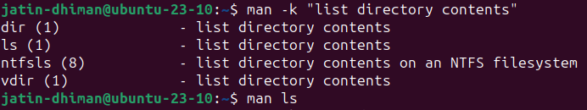

**-m :** This is used to change the modification time only. It only updates last modification time

1. **echo Command**

* The echo command can be used for displaying a line of string/text that is passed as the **arguments**
* echo [option] [string]



* The shell expands the “*” into something else (in this instance, the names of the files in the current working directory) before the echo command is executed.



* -e is used for the interpretation of backslash escapes.
* Pathname Expansions

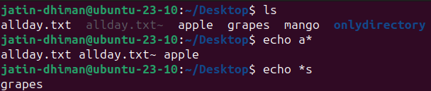

* Tilde Expansion



* Arithmetic Expansion

Arithmetic expansion uses the form: $((expression))



* Brace Expansion

With it, you can create multiple text strings from a pattern containing braces.

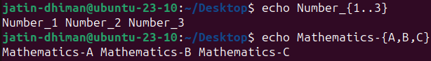

* Word-splitting by the shell removed extra whitespace from the echo command's list of arguments





* Any file beginning with an uppercase letter



**COMMON OPTIONS IN echo COMMAND**

**\b :** It removes all the spaces in between the text



**\c :** It suppress trailing new line with backspace interpretor ‘-e‘ to continue without emitting new line



**\n :** his option creates new line from where it is used.

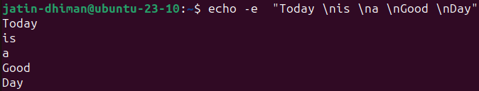

**\t :** This option is used to create horizontal tab spaces.



**\r :** Carriage return with backspace interpretor ‘-e‘ to have specified carriage return in output, i.e. it only prints the text after ‘\r’



**\v :** his option is used to create vertical tab spaces.

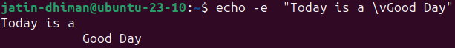

**\a :** Alert return with backspace interpretor ‘-e‘ to have sound alert.



**-n :** This option is used to omit echoing trailing newline

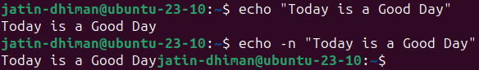

**echo* :** This command will print all files/folders, similar to ls command .



1. **cat Command**

* It can be used **to display the content of a file**, copy content from one file to another, concatenate the contents of multiple files, display the line number, display $ at the end of the line, etc.
* cat fileName

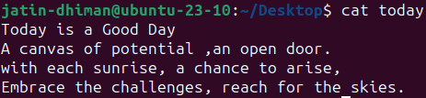

* To **display the content of multiple files** at once, type file names in one single line like **"cat file1 file2 file3... fileN.**
* The 'cat' command can be used to **create a new file** with greater than sign **(>)**.



* The 'cat' command with double greater than sign **(>>)** **append** (add something in the last of a file) something in your already existing file.

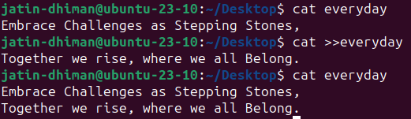

* The 'cat' command can be used **to copy the content of a file into another file**.

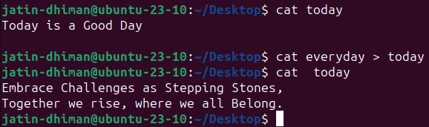

* The 'cat' command can be used **to concatenate** the contents of multiple files in a single new file.

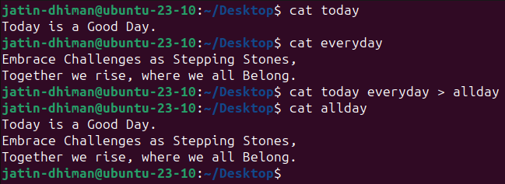

* A **new line** will be **inserted** while concatenating multiple files by using a hyphen (-)

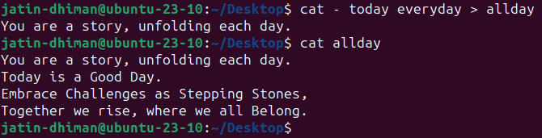

* cat command can be used to redirect standard error(1 for standard output and 2 for standard input)

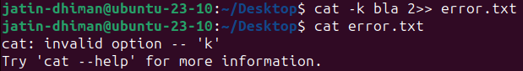

**COMMON OPTIONS IN cat COMMAND**

* **-n :** Number all output lines.

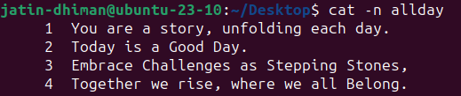

* **-b :** The 'cat -b' option removes the empty lines.

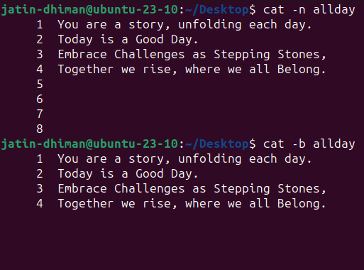

* **-e :** The 'cat-e' option displays a **'$'** sign at the end of every line.

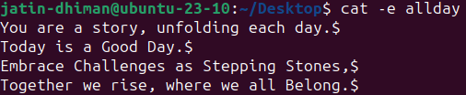

* **-s :** Suppress repeated empty output lines. The -s option will ensure that if there are multiple consecutive empty lines in the file, only one empty line will be displayed.

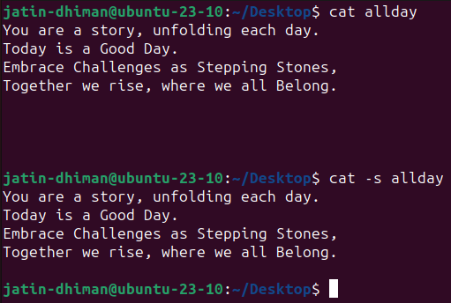

* **-T :** Displays tab characters as ^I.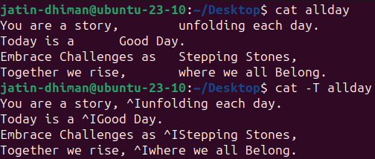
* **Cat f - g :** Outputs f’s contents, then standard input, then g’s contents. Here, the contents of ‘hello’ will be displayed first, then any input you type will be shown, and finally, the contents of ‘world’ will be displayed.

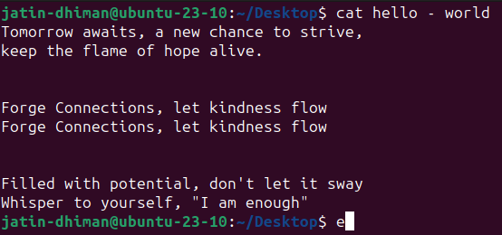

* **-A :** The -A option in the cat command is equivalent to combining the -v, -E, and -T options

-v: Displays non-printing characters (control characters) using the ^ notation.

-E: Appends a $ character at the end of each line.

-T: Displays tab characters as ^I

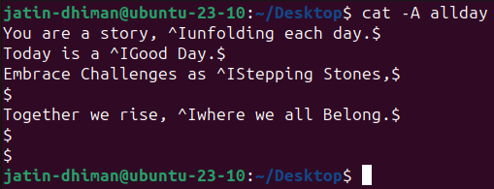

1. **who Command**

* Whenever a user needs to know about how many users are using or are logged-in into a particular Linux-based operating system, he/she can use the "who" command to get that information
* who [options] [filename]

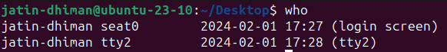

* who command is used to find out the following information :

1. Time of last system boot

2. Current run level of the system

3. List of logged in users and more.

* The who command is used to get information about currently logged inuser on to system.

1. **whoami Command**

* print effective userid
* whoami [options]

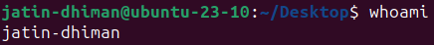

**COMMON OPTIONS IN whoami COMMAND**

* **--help :** Display help and exit

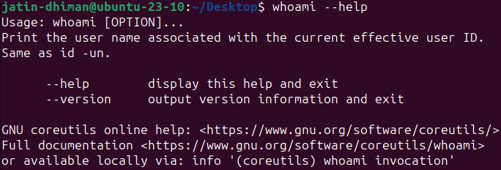

* **--version :** output version information and exit

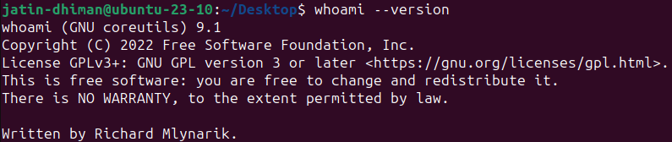

1. **wc Command**

* Linux wc command helps in counting the lines, words, and characters in a file. It displays the number of lines, number of characters, and the number of words in a file. Mostly, it is used with pipes for counting operation.
* By default it displays four-columnar output.
* First column shows number of lines present in a file specified, second column shows number of words present in the file, third column shows number of characters present in file and fourth column itself is the file name which are given as argument.
* wc filename

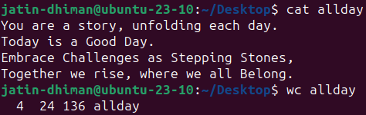

* To display the complete count information of multiple files at once, specify the file names after space (' ').

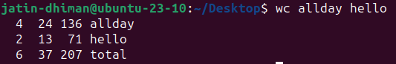

**COMMON OPTIONS IN wc COMMAND**

* **-l :** This option prints the number of lines present in a file.With this option wc command displays two-columnar output,1st columns hows number of lines present in a file and 2nd itself represent the file name.



* **-w :** This option prints the number of words present in a file.With this option wc command displays two-columnar output,1st column shows number of words present in a file and 2nd is the file name.



* **-c :** This option displays count of bytes present in a file. With this option it display two-columnar output,1st columns hows number of bytes present in a file and 2nd is the file name.



* **-m :** Using -m option ‘wc’ command displays count of characters from a file.



* **-L :** It can be used to print out the length of longest (number of characters) line in a file.



* **ls | wc -l :** This command displays the count of the files from the current working directory



1. **cp Command**

* cp stands for copy.This command is used to copy files or group of files or directory. It creates an exact image of a file on a disk with different filename.cp command require at least two filenames in its arguments.
* cp [OPTION] Source Destination

cp [OPTION] Source Directory

cp [OPTION] Source-1 Source-2 Source-3 Source-n Directory.

* Using first and second syntax,we can copy files from source to destination,while third syntax copies multiple files into the directory.

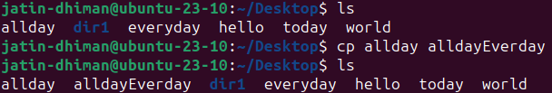

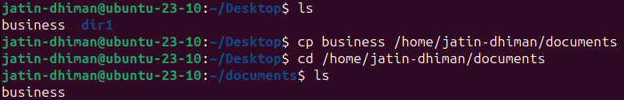

**COMMON OPTIONS IN cp COMMAND**

* **-r :** With this option cp command shows its recursive behavior by copying the entire directory structure recursively.

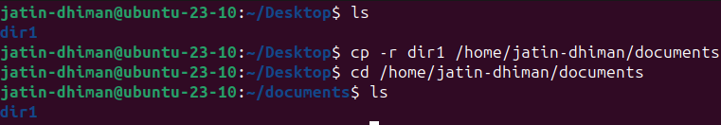

* **-i :** With this option system first warns the user before overwriting the destination file. Cp prompts for a response, if you press y then it overwrites the file and than y other option leave it uncopied..

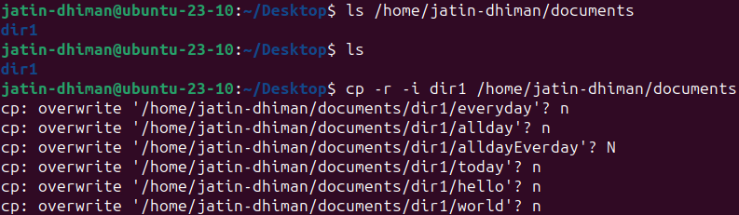

* **-b :** With this option cp command creates the backup of the destination file in the same folder with the different name and in different format.
* **-f :** If the system is unable to open destination file for writing operation because the user doesn’t have writing permission for this file then by using -f option with cp command.

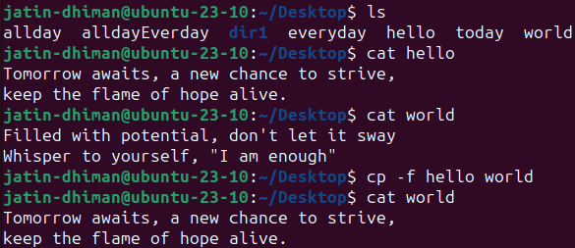

* **-p :** preserves the following characteristics of eachsource file in thecorresponding destinationfile: thetimeof thelastdatamodificationandthetimeof thelastaccess, the ownership (only if it has permissions to do this), and the file permission-bits.

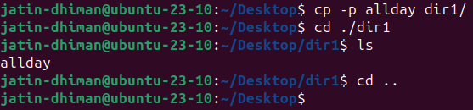

* **Wildcard,* :** It is used to copy all the files of the same syntax, recursively.



1. **mv Command**

* Linux mv command is used to move existing file or directory from one location to another. It is also used to rename a file or directory. If you want to rename a single directory or file then **'mv'** option will be better to use.
* **Two Distinct Functions of `mv` Command**

1. Renaming a file or directory.

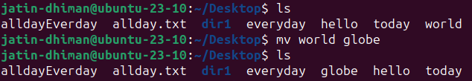

1. Moving a file or directory to another location

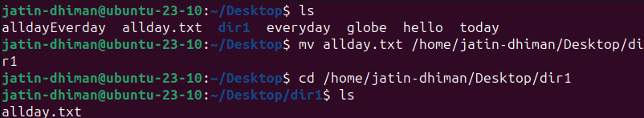

* Moving Multiple Files

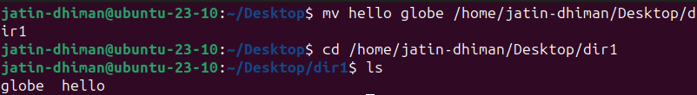

* Renaming a Directory

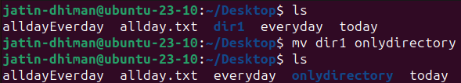

**COMMON OPTIONS IN mv COMMAND**

* **-i :** -i option makes the command ask the user for confirmation before moving a file that would overwrite an existing file, you have to press y for confirm moving, any other key leaves the file as it is.

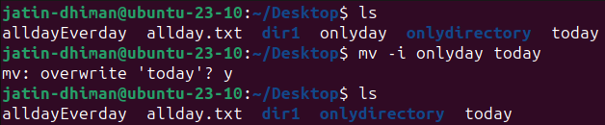

* **-f :** -f option overrides this minor protection and overwrite the destination file forcefully and delete the source file.

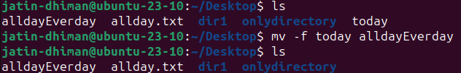

* **-n :** mv prevent an existing file from being overwritten.

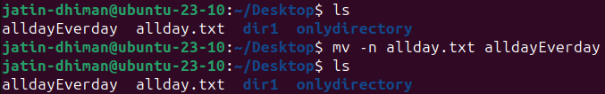

* **-b :** With this option it is easier to take a backup of an existing file that will be overwritten as a result of the mv command. This will create a backup file with the tilde character(~) appended to it.

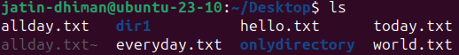

1. **rm Command**

* It remove files or directories. Rm removes each specified file.By default, it does not remove directories.

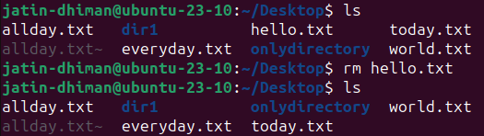

**COMMON OPTIONS IN rm COMMAND**

* **-i :** prompt before every removal

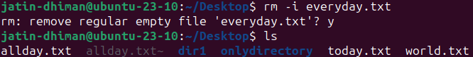

* **-f :** -f option overrides this minor protection and overwrite the destination file forcefully and delete the source file.

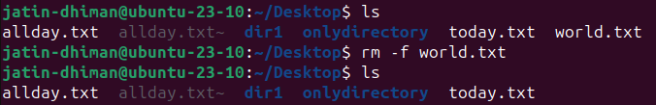

* **-I :** prompt once before removing more than three files, or when removingrecursively; less intrusive than-i,while still giving protection against most mistakes

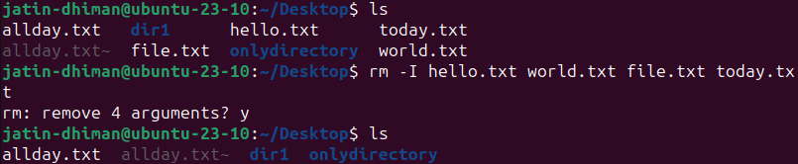

1. **rmdir Command**

* It removes an empty directory on various operating systems..
* rmdir name_of_directory

where name_of_directory corresponds with the name of the directory one wishes to delete.

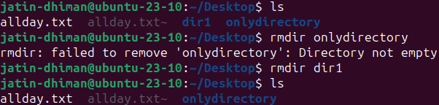

1. **tty Command**

* The tty command of terminal basically prints the filename of the terminal connected to standard input. Tty is short of teletype,but popularly known as a terminal it allows you to interact with the system by passing on the data(youinput) to the system,and displaying the output produced by the system.
* tty [OPTION]...

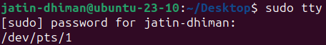

**COMMON OPTIONS IN tty COMMAND**

* **--version :** Prints the version of tty

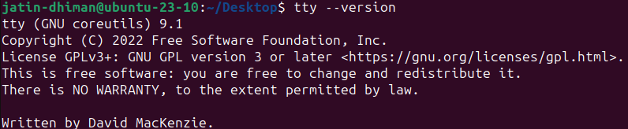

* **--help :** It will display the help message and exit.

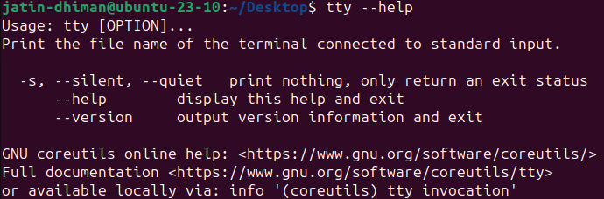

* **-s, -silent , -quiet :** Prints nothing, only returns an exit status.

**Practical:- 3**

**Commands**

1. **whatis Command**

* The **whatis** command is used to get brief information about Linux commands or functions. It displays the manual page description in a single line of the command that passes with the whatis command. It searches for the strings that have been passed with it from its index databases.
* One liner for manual pages



1. **whereis Command**

* Whereis command is used to find the location of souce/binary file of a command.
* Find and whereis command are similar but whereis command produces the result more accurately by consuming less time comparatively.



**COMMON OPTIONS IN whereis COMMAND**

* -**b:** This option is used when we only want to search for binaries.



* -**m:** This option is used when we only want to search for manual sections.



1. **find Command**

* The find command helps us to find a particular file within a directory. It is used to find the list of files for the various conditions like permission, user ownership, modification, date/time, size, and more.
* **find** [where to start searching from] [expression determines what to find] [-options] [what to find]
* Find files by name

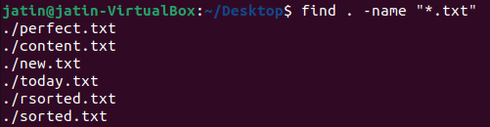

* Finding files by type

The '-type' parameter is used to specify the file type. Types are:

* f: regular file
* d: directory
* l: symbolic links
* c: character devices
* b: block devices

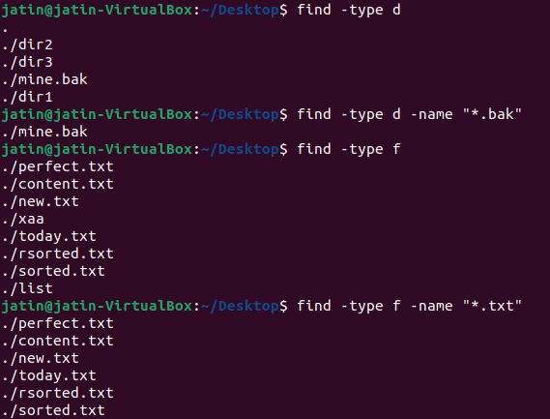

* Find newer files

The '-newer' parameter helps in searching the files which are newer than the mentioned file.

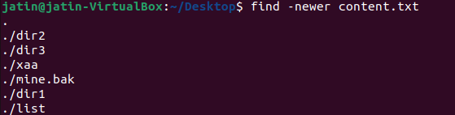

* Find and delete a file

The '-delete' option is used to delete a specific file. We need to be very careful while using this command because there is no undo option if it is once executed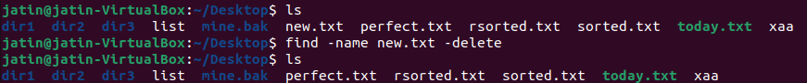

* Find files by permission

The '-perm' option is used to find files by permission

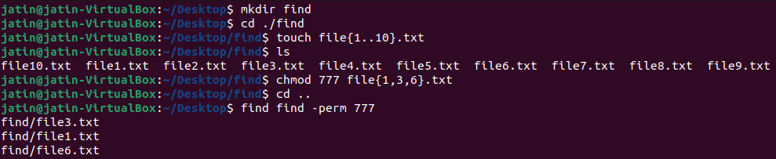

1. **type Command**

* This command is used to describe how its argument would be translated if used as commands. It is also used to find out whether it is built-in or external binary file.
* It shows a command’s type and location
* type [OPTIONS] command names



**COMMON OPTIONS IN type COMMAND**

* -**a:** This option is used to find out whether it is an alias, keyword or a function and it also displays the path of an executable, if available.
* -**t:** This option will display a single word as an output.

alias – if command is a shell alias

keyword – if command is a shell reserved word

builtin – if command is a shell builtin

function – if command is a shell function

file – if command is a disk file

* **-p:** This option displays the name of the disk file which would be executed by the shell. It will return nothing if the command is not a disk file

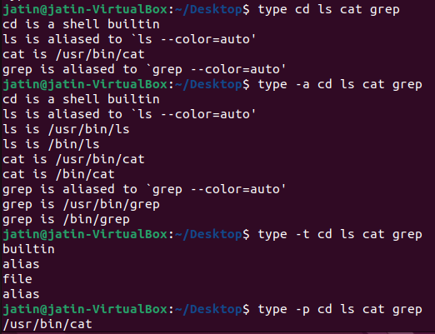

1. **bc(basic calculator) Command**

* bc command is used for command line calculator. It is similar to basic calculator by using which we can do basic mathematical calculations.
* echo and expr can also be used for calculations but don’t support floating point numbers

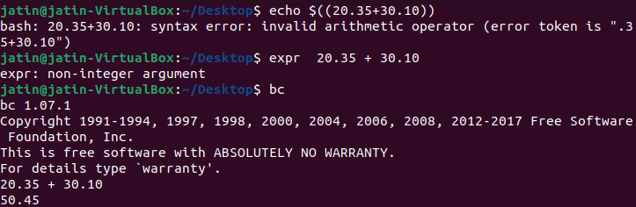

* bc [ -hlwsqv ] [long-options] [ file ... ]
* Can use calculator using pipe with echo



* Scale in bc to get precision

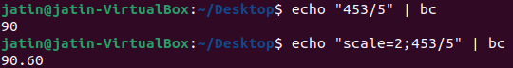

* Arithmetic Operator

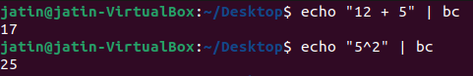

* Assignment Operator

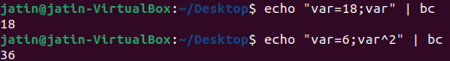

* Increment Operator

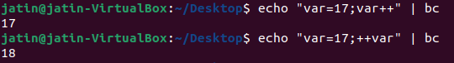

* Decrement Operator

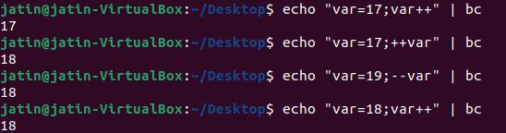

* Relational Operator

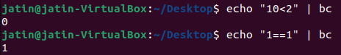

**COMMON OPTIONS IN bc COMMAND**

* -**a:** This option is used to find out whether it is an alias, keyword or a function and it also displays the path of an executable, if available.
* -**t:** This option will display a single word as an output.

alias – if command is a shell alias

keyword – if command is a shell reserved word

builtin – if command is a shell builtin

function – if command is a shell function

file – if command is a disk file

* **-p:** This option displays the name of the disk file which would be executed by the shell. It will return nothing if the command is not a disk file

1. **expr Command**

* The **expr command** is used to evaluate a given expression and display its standard output. Each separated expression is considered as an argument. These expressions could be integer and string expressions, including regular expressions.
* The expr command supports the following operators:
* **for integer:** addition, subtraction, multiplication, division, and modulus.
* **For strings:** regular expression, set of characters in a string.
* expr expression
* **Basic arithmetic operations using expr command**
* **Addition**

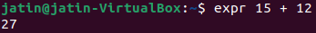

* **Subtraction**

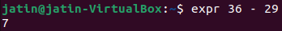

* **Multiplication**

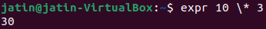

* **Division**



* **Find the length of a string**



* **Find the position of character in a string**



* **Find the substring from a string**



* **Match the numbers of characters in two strings**



* **Find the modulus value**



* **Comparing two expressions**

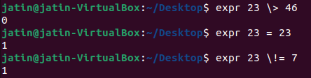

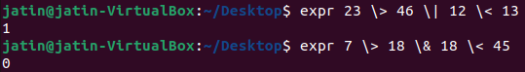

1. **diff Command**

* It is a command that you can use to determine what is different between one file and another, when you use it special symbols will appear that will give you a better idea of what changes you would have to make in order to make file identical
* We can use -s to get a prompt if the files are identical. Here first.txt and only.txt are identical



* Some special symbols are used by diff command. These are:- a : add c : change d : delete

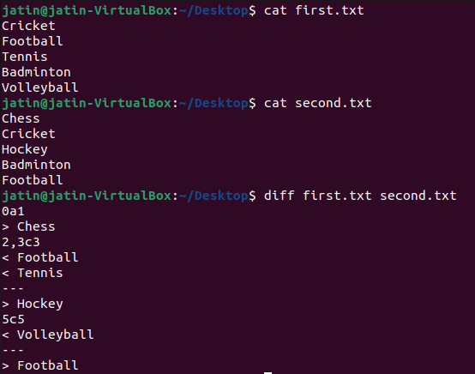

1. **sort Command**

* The command sorts the lines of text files. It writes sorted concatenation of all FILE(s) to standard output.
* The 'sort' command sorts the file content in an alphabetical order.

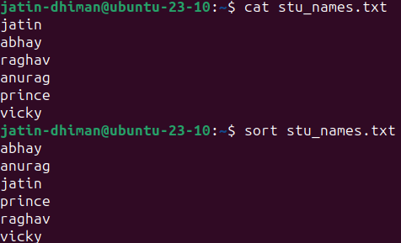

* Saving sorted Content to a new file

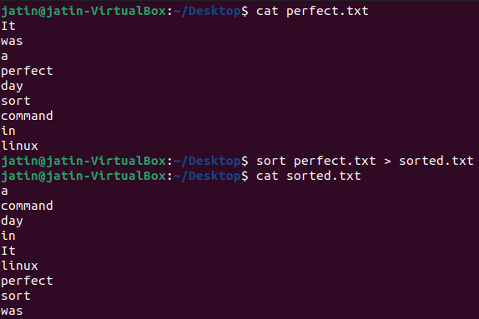

* Reverse sort

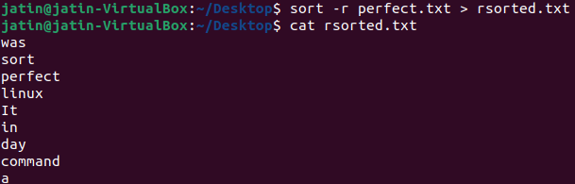

* Sorting and merging two files

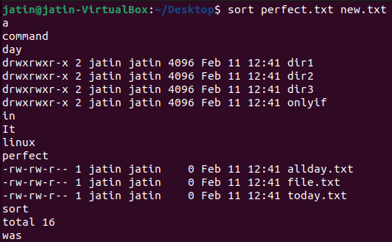

**COMMON OPTIONS IN sort COMMAND**

* **-f :** --ignore-case

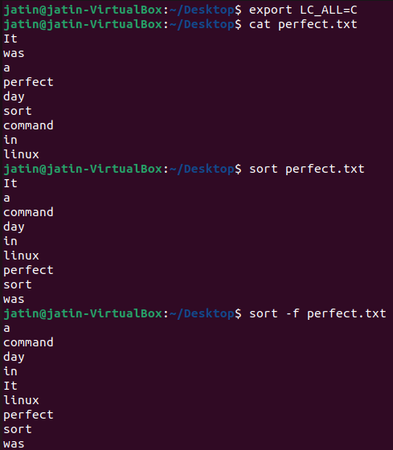

1. **grep Command**

* Grep, short for “global regular expression print”, is a command used for searching and matching text patterns in files contained in the regular expressions.

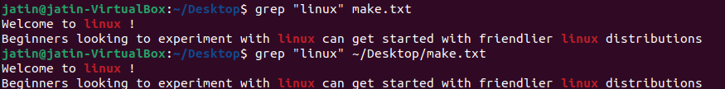

**COMMON OPTIONS IN grep COMMAND**

* **-i :** The -i option enables to search for a string case insensitively in the given file. It matches the words like “tODay”, “Today”, “today”.

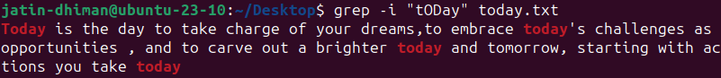

* **-c :** We can find the number of lines that matches the given string/pattern



* **-l :** We can just display the files that contains the given string/pattern.

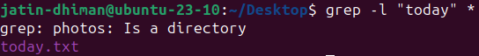

* **-E :** Interpret PATTERN as an extended regular expression (ERE, see below)

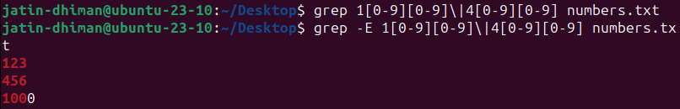

* **-n :** To number the lines where the string pattern is matched



1. **ulimit Command**

* get and set user limits

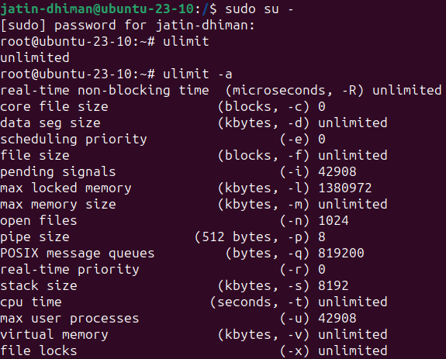

* We can change for example stack size for a user at an instant, Here stack size is modified from 8192 to 4000

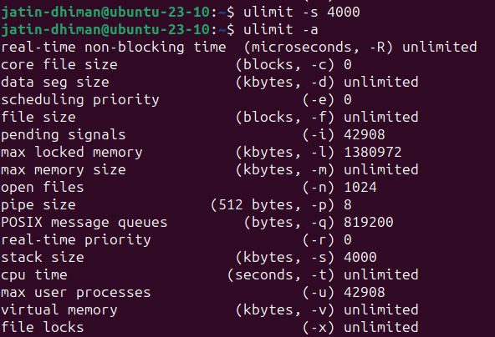

1. **du Command**

* estimate the file space usage

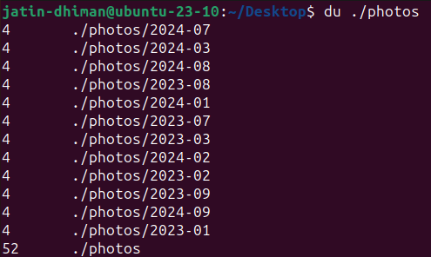

**COMMON OPTIONS IN du COMMAND**

* **-a :** write counts for all files, not just directories

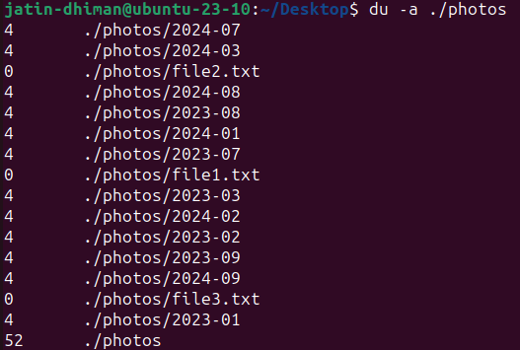

* **-a :** end each output line with NUL, not newline



* **-B :** Scale sizes by SIZE before printing them; e.g., '-BM' print sizes in units of 1,048,576 bytes;
* **-b :** equivalent to '--apparent-size –block-size=1'

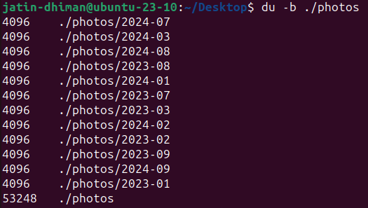

* **-c :** produce a grand total

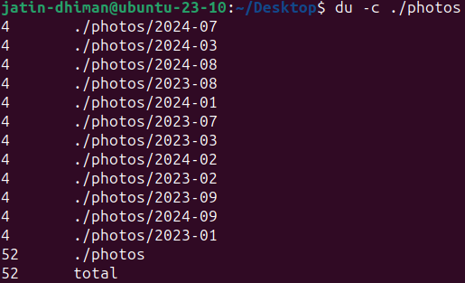

1. **free Command**

* Display amount of free and used memory in the system

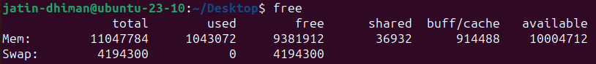

**COMMON OPTIONS IN free COMMAND**

* **-b :** Display the amount of memory in bytes.

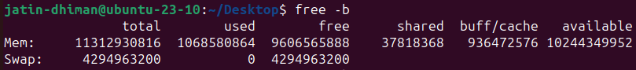

* **-k :** Display the amount of memory in kibibytes. This is the default

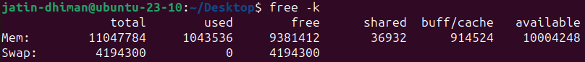

* **-m :** Display the amount of memory in mebibytes.

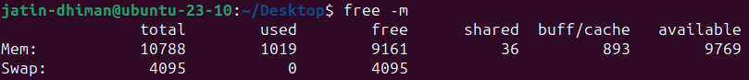

* **-g :** Display the amount of memory in gibibytes.



1. **head Command**

* output the first part of files
* Without any option, it displays only the first 10 lines of the file specified

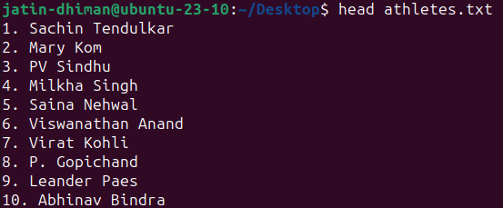

**COMMON OPTIONS IN head COMMAND**

* **-n :** print the first NUM lines instead of the first 10; with the leading '-', print all but the last NUM lines of each file

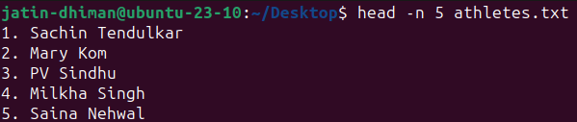

* **-c :** print the first NUM bytes of each file; with the leading '-', print all but the last NUM bytes of each file



* **-v :** always print headers giving file names

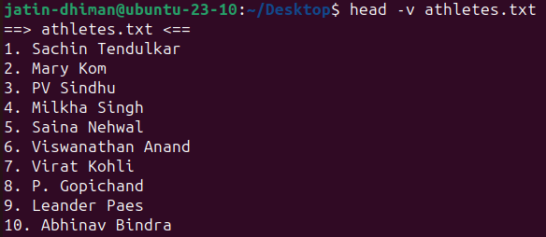

* **-z :** line delimiter is NUL, not newline

1. **tail Command**

* output the last part of files
* Without any option, it displays only the last 10 lines of the file specified

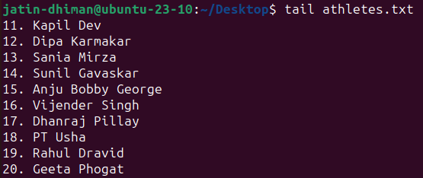

**COMMON OPTIONS IN tail COMMAND**

* **-c :** output the last NUM bytes; or use -c +NUM to output starting with byte NUM of each file

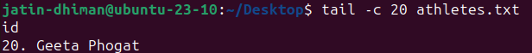

* **-f :** output appended data as the file grows; an absent option argument means 'descriptor-'

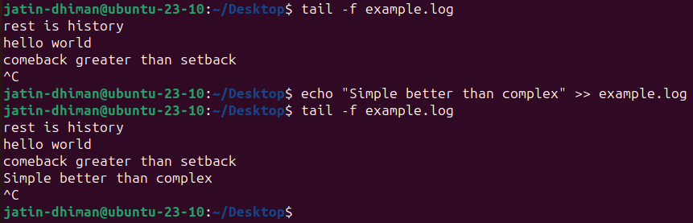

* **-F :** same as --follow=name --retry
* **-n :** output the last NUM lines, instead of the last 10; or use -n +NUM to output starting with line NUM

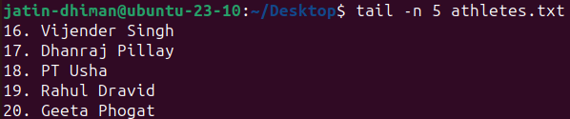

* **-q :** never output headers giving file names

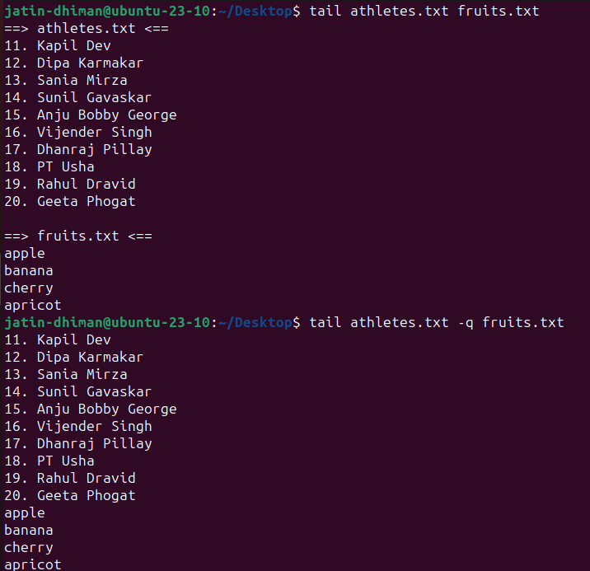

* **-s :** with -f, sleep for approximately N seconds (default 1.0) between iterations; with inotify and --pid=P, check process P at least once every N seconds
* **-v :** always output headers giving file names

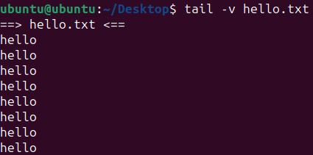

* **-z :** line delimiter is NUL, not newline

1. **tr Command**

* translate or delete characters
* tr [OPTION]... SET1 [SET2]
* Change Case

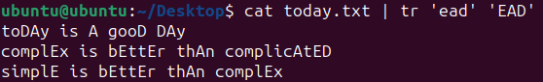

**COMMON OPTIONS IN tr COMMAND**

* **-c :** use the complement of SET1 The -c option complements the specified character set. Here, it replaces all non-vowel characters with an asterisk.



* **-d :** delete characters in SET1, do not translate

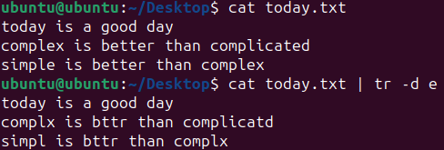

* **-s :** replace each sequence of a repeated character that is listed in the last specified SET, with a single occurrence of that character





* **-t :** first truncate SET1 to length of SET2

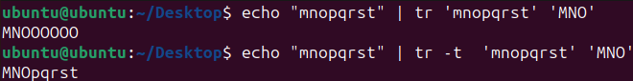

* **--help :** display this help and exit

1. **cut Command**

* remove sections from each line of files
* cut OPTION... [FILE]...

**COMMON OPTIONS IN cut COMMAND**

* **-c :** The '-c' option is used to cut a specific section by character. However, these character arguments can be a number or a range of numbers, a list of comma-separated numbers, or any other character.

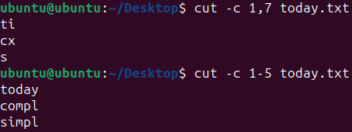

* **-b :** select only these bytes

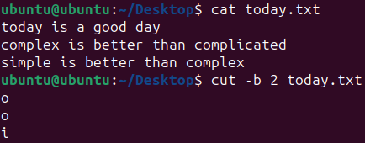

* **-d :** use DELIM instead of TAB for field delimiter

cut -d ' ' -f(columnNumber) <fileName>

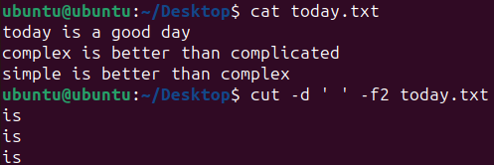

* **--complement :** complement the set of selected bytes, characters or fields

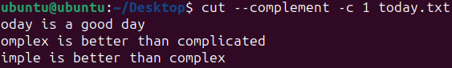

* **--version:** display this help and exit

1. **tee Command**

* Thiscommandreads thestandard inputandwrites it toboththestandardoutputand oneormore files. It basicallybreaks theoutput of aprogramsothat it canbeboth displayedandsaved inafile. It does boththetaskssimultaneously, copiestheresult into the specified files or variables and also display the result.
* tee [OPTION]... [FILE]...
* The tee command is used to write a standard input to standard output and a file. It is used after a pipe. To write to standard output and a file, specify the tee command after a pipe and provide the file(s) name.

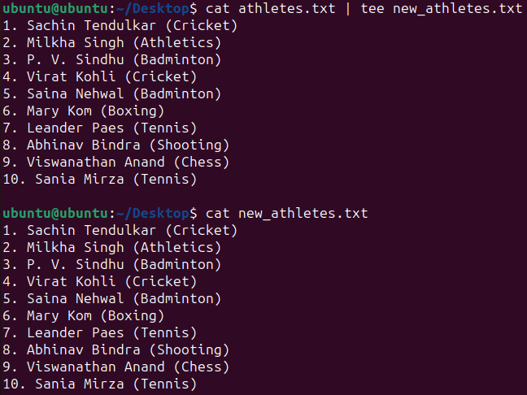

* Writing to multiple files

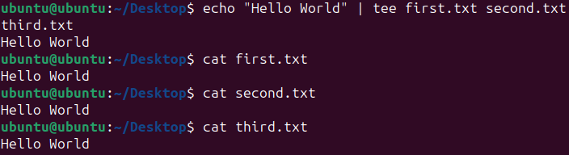

**COMMON OPTIONS IN tee COMMAND**

* **-a :** The '-a' option is used with the tee command to append the output and write it to a file

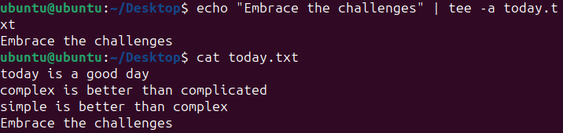

1. **comm Command**

* The 'comm' command compares two files or streams. By default, 'comm' will always display **three columns**. First column indicates non-matching items of first file, second column indicates non-matching items of second file, and third column indicates matching items of both the files. Both the files has to be in sorted order for 'comm' command to be executed.
* comm [OPTION]... FILE1 FILE2

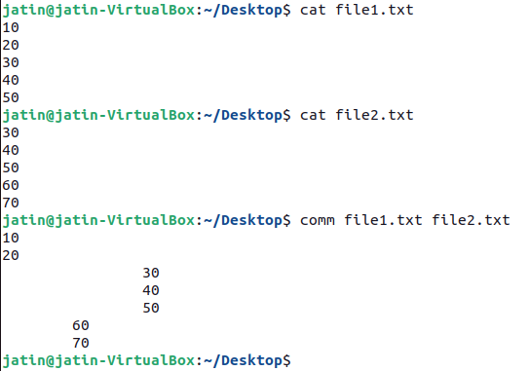

**COMMON OPTIONS IN comm COMMAND**

* **-1:** suppress column 1 (lines unique to FILE1)
* **-2:** suppress column 2 (lines unique to FILE2)
* **-3:** suppress column 3 (lines that appear in both files)

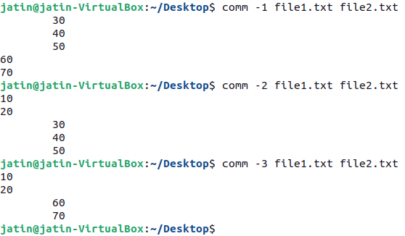

* **--total:** output a summary

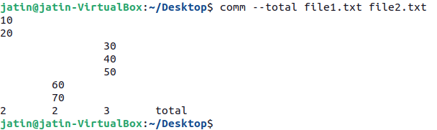

**Practical:- 4**

**Commands**

1. **Chmod command**

* You can see the permission for any file or directory by typing the ls -ld command.

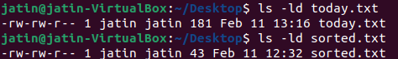

* Changing permissions with chmod (numbers)
* Each permission (read, write, and execute) is assigned a number—r=4, w=2, and x=1—and you use each set’s total number to establish the permission.

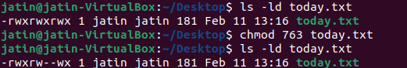

* Permission denied if we tried to access today.txt

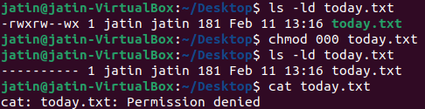

* Changing permissions with chmod (letters)
* You can also turn file permissions on and off using plus (+) and minus (–) signs, respectively, along with letters to indicate what changes and for whom. Using letters, for each fi le you can change permission for the user (u), group (g), other (o), and all users (a). What you would change includes the read (r), write (w), and execute (x) bits.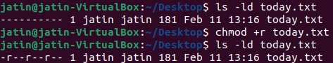
* Giving write permission only to user

Here “=” deletes all the previous permissions and assign only the write permission to user.

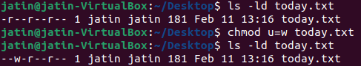

To add read permission also to user

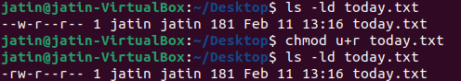

**COMMON OPTIONS IN chmod COMMAND**

* **-R :** change files and directories recursively

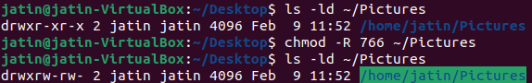

* **-v :** like verbose but report only when a change is made

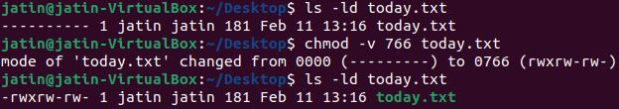

* **-c :** like verbose but report only when a change is made

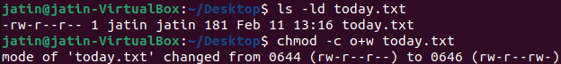

* **-f :** suppress most error messages

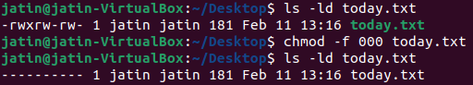

1. **umask command**

* When you create a file as a regular user, it’s given permission rw-rw-r-- by default. A directory is given the permission rwxrwxr-x. For the root user, file and directory permission are rw-r--r-- and rwxr-xr-x, respectively. These default values are determined by the value of umask.
* The umask command is used to set this mask,or to show you it scurrent value.The default creation permissions for files are 666 and for directories 777. Forexample, to calculate how uname 022 will affect newly created files and directories, use: Files: 666-022=644. The owner can read and modify the files.Group and others can only read the files. Directories:777-022=755.The owner can cd into the directory and list read, modify, create or delete the files in the directory.Group and others can cd into the directory and list and read the files.

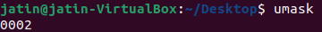

* To set a specific umask

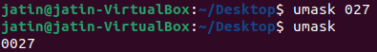

**COMMON OPTIONS IN umask COMMAND**

* **-p :** if MODE is omitted, output in a form that may be reused as input

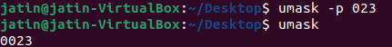

* **-S :** makes the output symbolic; otherwise an octal number is output



1. **gzip command**

* The gzip program is used to compress one or more files. When executed, it replaces the original file with a compressed version of the original. The corresponding gunzip pro gram is used to restore compressed files to their original, uncompressed form.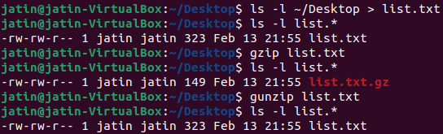

**COMMON OPTIONS IN gzip COMMAND**

* **-c :** Write output on standard output; keep original files unchanged.

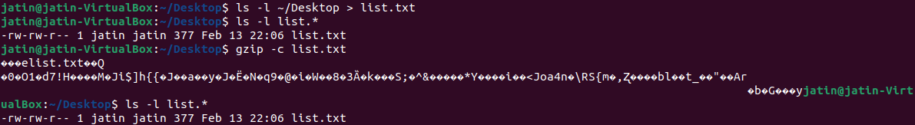

* **-d :** Decompress. This causes gzip to act like gunzip. May also be specified with --decompress or --uncompress.

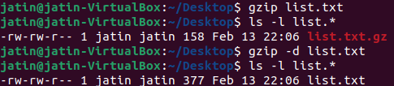

* **-f :** Force compression even if a compressed version of the original file already exists. May also be specified with --force.

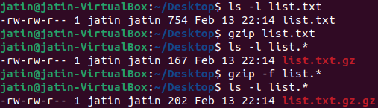

* **-h :** Display usage information. May also be specified with --help.

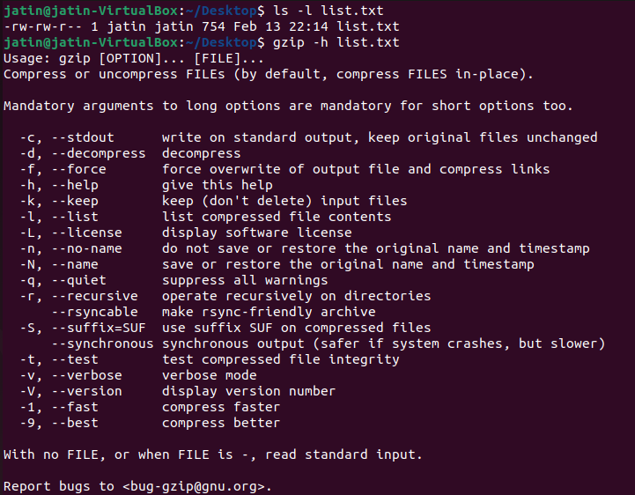

* **-l :** For each compressed file, list the following fields: compressed size: size of the compressed file uncompressed size: size of the uncompressed file ratio: compression ratio (0.0% if unknown) uncompressed_name: name of the uncompressed file

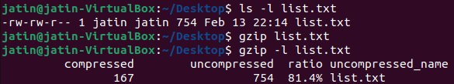

* **-v :** Display the name and percentage reduction for each file compressed or decompressed.



* **-v :** Display the name and percentage reduction for each file compressed or decompressed.



1. **tar command**

* The tar  command is used to create an archive, grouping multiple files in a single file.
* Its name comes from the past and means tape archive. Back when archives were stored on tapes.
* This command creates an archive named archive.tar  with the content of file1  and file2 :

The c  option stands for create. The f  option is used to write to file the archive.



* List the files contained in an archive

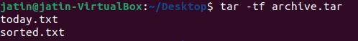

* To extract them to a specific directory, use:

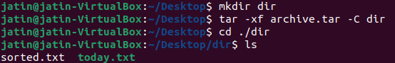

1. **split command**

* Split command in Linux is used to split large files into smaller files

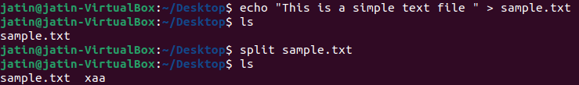

**COMMON OPTIONS IN split COMMAND**

* **-a:** generate suffixes of length N (default 2)

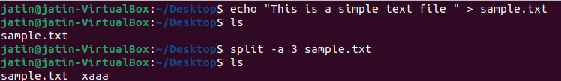

* **-additional-suffix=SUFFIX:** append an additional SUFFIX to file names

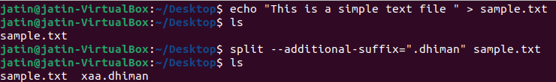

* **-b:** put SIZE bytes per output file

This will split the file into parts, each containing 10 bytes.

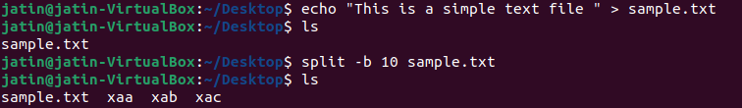

* **-C:** put at most SIZE bytes of records per output file

This will split the file into parts, each containing up to 20 bytes of records.

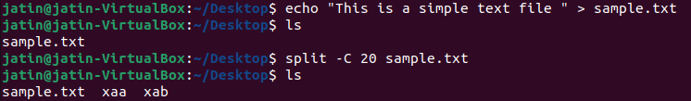

* **-d:** use numeric suffixes starting at 0, not alphabetic

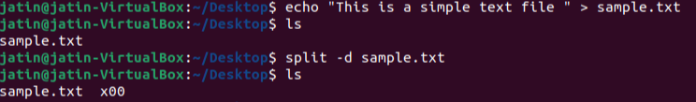

* **--numeric-suffixes[=FROM]:** same as -d, but allow setting the start value

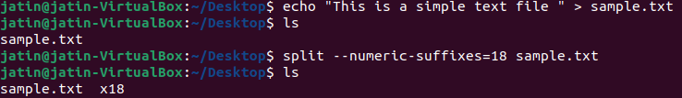

* **--verbose:** print a diagnostic just before each output file is opened

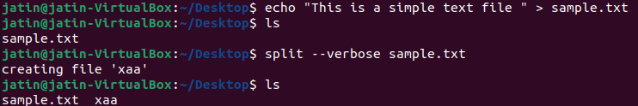

1. **sleep command**

* delay for a specified amount of time



Sleep as a background process

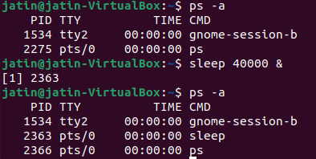

1. **shutdown command**

* Halt, power-off or reboot the machine

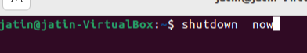

**COMMON OPTIONS IN shutdown COMMAND**

* **-r:** Reboot the machine.

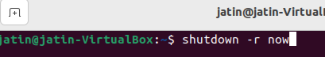

* **-P:** Output version info and exit

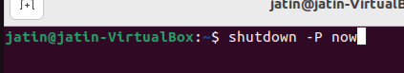

1. **adduser command(*)**

* add a user to the system

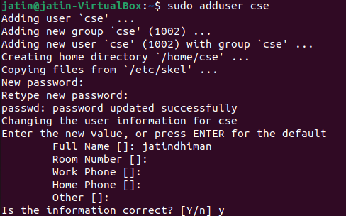

* Displaying user using cat /etc/passwd

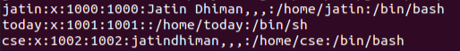

1. **su command**

* change user ID or become superuser

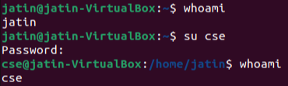

1. **deluser**

* remove a user from the system

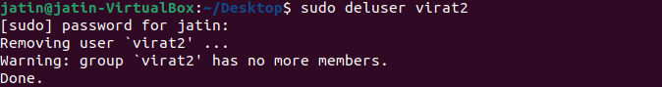

1. **chown**

* change file owner and group

Working of chown

We couldn’t append in file.txt in user’s terminal as root was the owner earlier, we can change the ownership using chown and let user append in the file.txt

**Terminal-1 (root user)**

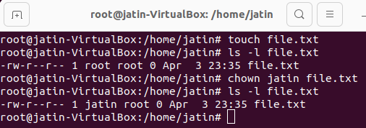

**Terminal-2 (jatin user)**

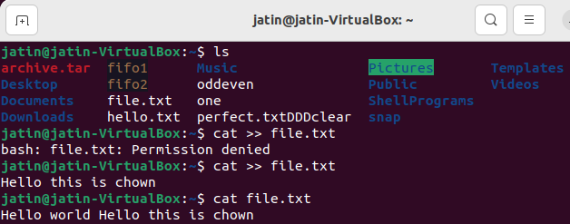

**COMMON OPTIONS IN chown command**

* **-c:** like verbose but report only when a change is made

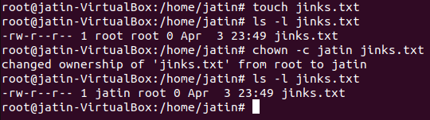**Practical:- 5**

**Commands**

1. **ps command**

* The ps command is used for checking running process.

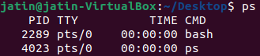

PID - Process ID gives the unique identification number of the process

TTY – terminal type

Time – Cpu utilization time by the process

CMD – command used by the process

**COMMON OPTIONS IN ps COMMAND**

* **-A:** to view all the running process

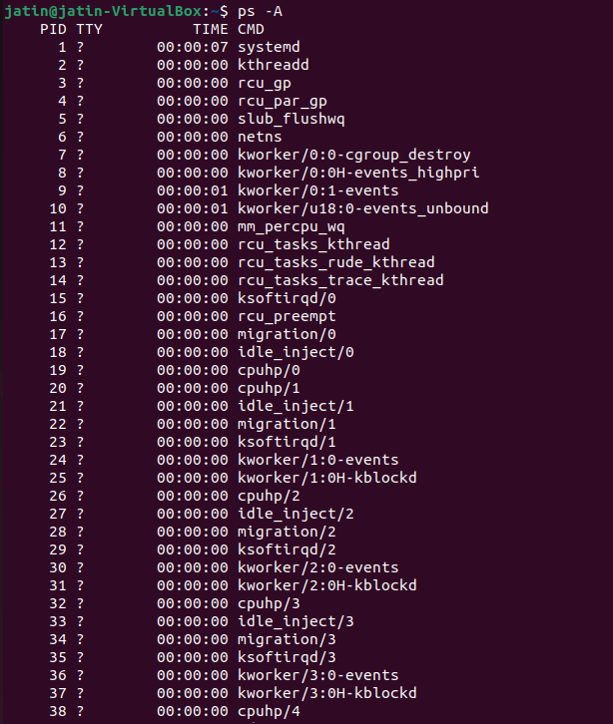

* **-C:** gives information about a particular process

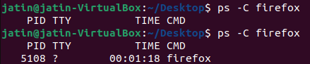

* **-u:** if we want to check running process for particular user

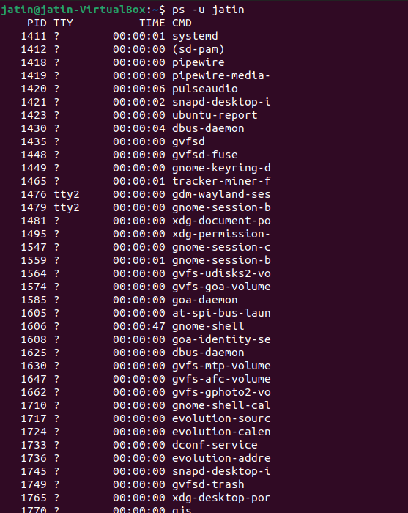

* **-fp:** Listing processes by PID

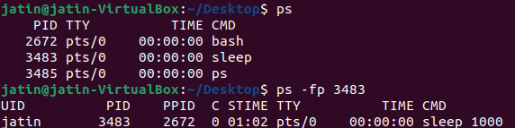

* **-C:** Search Process PID

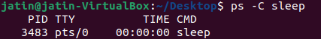

* **-a:** View processes not associated with terminal

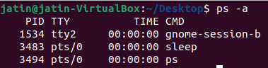

* **-T:** View processes associated with the terminal

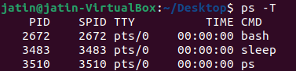

1. **nohup (no hangup)**

* If you want your process keep running even after closing your terminal, you can use nohup
* Nohup, short for nohangup is a command in Linux systems that keep processes running even after exiting the shell or terminal.Nohup prevents the processesor jobs from receiving the SIGHUP(SignalHangUP) signal.This is a signal that is sent to a process upon closing or exiting the terminal.
* Demonstration:

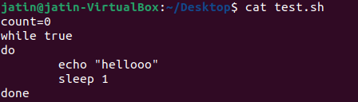

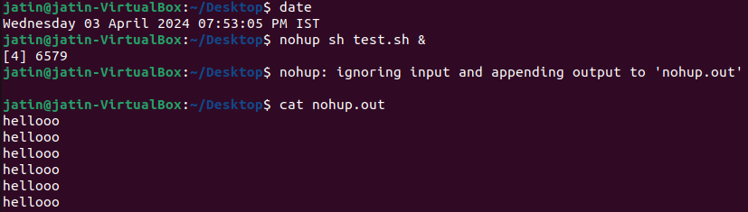

Closed the terminal – Process still running

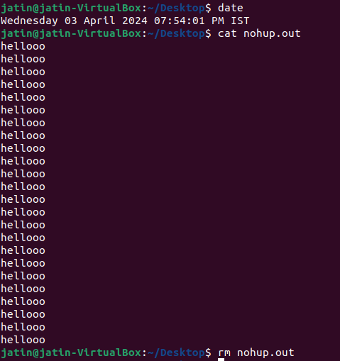

1. **Kill**

* Signals are used by operating system to notify a running process that an event has occurred
* Signals are given to processes when they perform something which they are not supposed to do
* A process did something
  + Accessed an illegal memory SIGSEGV(11) // segmentation fault
  + Division by 0 SIGFPE(8) // floating point error
  + Execute illegal instruction SIGILL(4)
* During Interprocess communication Signals are used
* User send signal to foreground processes

<ctrl+c> SIGINT(2)

<ctrl+\> SIGQUIT(3)

<ctrl+z> SIGTSTP(20)

* If we want to see all the signals supported on system

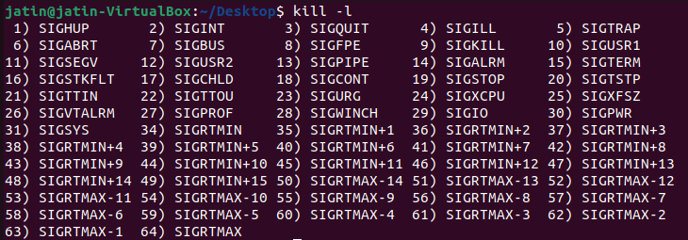

* SIGKILL and SIGSTOP signals can’t be ignored others are ignorable
* Sending Signal on same terminal

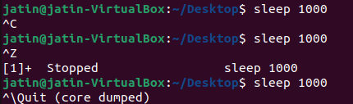

* To Send Signal on different terminal we can use kill command with the id of that process kill command by default sends SIGTERM(15) signal



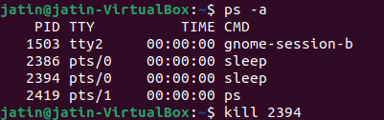



* We can mention signal no. as well in kill command



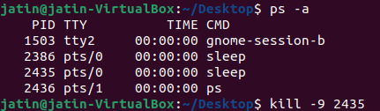



1. **Nice**

* run a program with modified scheduling priority
* Here scheduling priority of pid 2449 is being changed using nice command

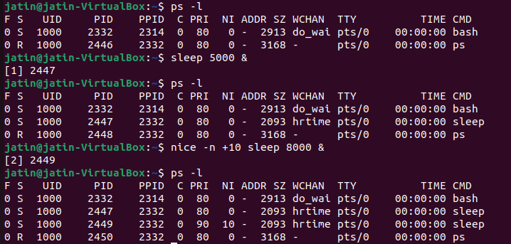

1. **At**

* To Schedule a task using the “at” command in Linux, you simply specify the time for the task followed by the task itself.
* The “at” command is a powerful tool for scheduling tasks to run at a specific time in the Linux environment.
* One time execution



**COMMON OPTIONS IN AT COMMAND**

* **-l:** Lists the user pending tasks

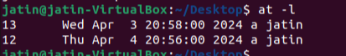

* **-t:** Run the job at time​, given in the format [[CC​]YY​]MMDDhhmm​[.ss​].

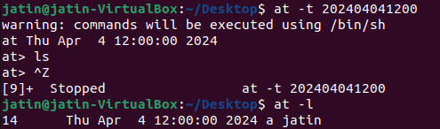

* **-f:** Reads the job from file​ rather than standard input

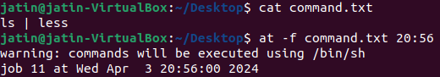

* **-r:** It removes a job from the at queue.

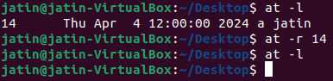

* **-v:** Showsthetimethejobwillbeexecutedbeforereadingthejob.Timesdisplayedwillbein the format "Thu Feb 20 14:50:00 1997".

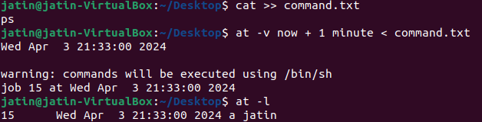

* **-c:** cats the jobs listed on the command line to standard output.

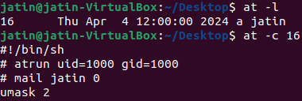

1. **batch**

* sed to read commands from standard input or a specified file and execute them when system load levels permit i.e. when the load average drops below 1.5
* It is important to note that batch does not accepts any parameters.
* One time execution

Working with batch command

* Type batch and press enter you will see a prompt where you can enter commands and end it with <ctrl-d>

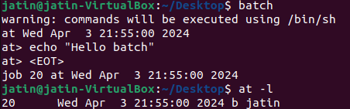

* Providing file containing commands to batch command for execution

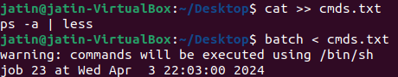

1. **crontab**

* The crontab is a list of commands that we want to run on a regular schedule, and also the name of the command used to manage that list.Crontab stands for “crontable, ” because it uses the job scheduler cron to execute tasks.
* To check the status of cron service – service cron status

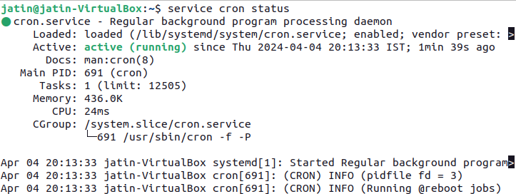

* Other similar commands service corn start, service cron stop, service cron restart
* To view the list of existing cron jobs in your crontab, use the command: crontab -l



* To add cronjob we can use crontab -e command

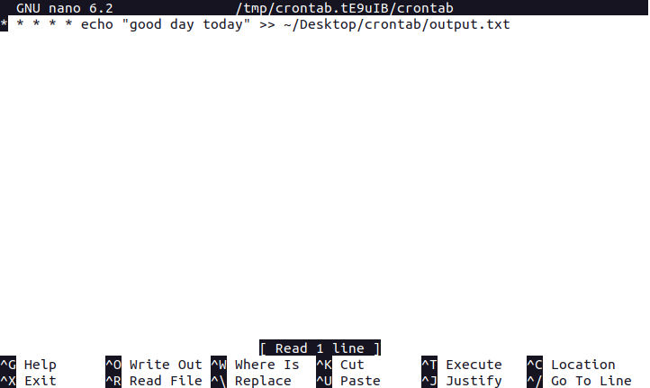

* Working of crontab

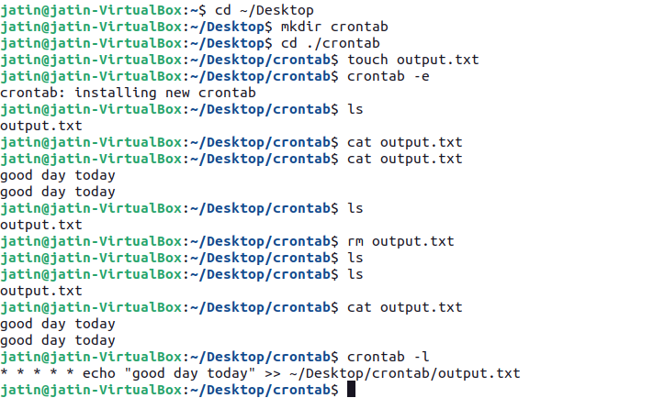

1. **wall**

* write a message to all users
* SYNOPSIS wall [-n] [-t timeout] [-g group] [message | file]

Write a message directly



**COMMON OPTIONS IN wall COMMAND**

* -**n --nobanner:** Suppress the banner.

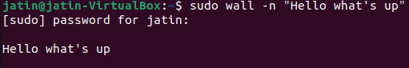

* **-t, --timeout:** Abandon the write attempt to the terminals after timeout seconds. This timeout must be a positive integer. The default value is 300 seconds,



* **-g, --group**: Limit printing message to members of group defined as a group argument.

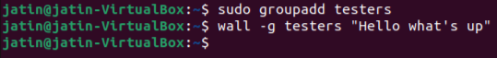

1. **Write**

* The write command sends a message to another user.The write utility allows you to communicate with other users by copying lines from your terminal to theirs.When you run the write command, the user you are writing to gets a message of the format:

**Practical - 6**

**Introduction to VI Editor**

Vim is an acronym for Vi IMproved. It is a free and open source text editor written by Bram Moolenaar. It was first released in 1991 for UNIX variants and its main goal was to provide enhancement to the Vi editor, which was released way back in 1976. Vim is considered as a clone Vi editor. Like Vi, it is also a command centric editor. One of the advantages of learning Vim is – it is available everywhere. Take any UNIX variant like Linux, Mac, HP-UX, AIX and many more, Vim is there by default. Vim traditionally does not have a GUI but now there is a separate installer called gVim which provides GUI.

**What is VI Editor?**

* The VI editor is the most popular and classic text editor in the Linux family.
* It is available in almost all Linux Distributions
* It works the same across different platforms and Distributions
* It works in two modes, Command and Insert.
* Command mode takes the user commands, and the Insert mode is for editing text .

**FEATURES OF VIM EDITOR:**

* It is command centric. You can perform complex text related task with few commands.
* It is highly configurable and uses a simple text file to store its configuration.
* There are many plug-in available for Vim. Its functionality can be extended in a great manner using these plug-in.
* It supports multiple windows. Using this feature , screen can be split into multiple windows.
* Same as multiple windows, it also supports multiple buffers.
* It supports multiple tabs which allows it to work on multiple files.
* It supports recording features which allows it to record and play Vim commands in a repeated manner

**How to use vi editor?**

To launch the VI Editor -Open the Terminal (CLI) and type

vi <filename_NEW> or <filename_EXISTING>

**Shell Scripting**

Shell Scripting is an open-source computer program designed to be run by the Unix/Linux shell. Shell Scripting is a program to write a series of commands for the shell to execute. It can combine lengthy and repetitive sequences of commands into a single and simple script that can be stored and executed anytime which, reduces programming efforts.

**What is shell?**

Shell is a UNIX term for an interface between a user and an operating system service. Shell provides users with an interface and accepts human-readable commands into the system and executes those commands which can run automatically and give the program’s output in a shell script.

**Types Of Shell**

There are two main shells in Linux:

**1. The Bourne Shell:** The prompt for this shell is $ and its derivatives are listed below:

POSIX shell also is known as sh

Korn Shell also known as sh

Bourne Again SHell is also known as bash (most popular)

**2. The C shell:** The prompt for this shell is %, and its subcategories are:

C shell also is known as csh

Tops C shell also is known as tcsh

**How to Write Shell Script in Linux/Unix**

Create a file using a Vi Editor . Name script file with extension .sh

Start the script with #! /bin/sh

Write some code.

Save the script file as filename.sh

For executing the script type bash filename.sh

"#!" is an operator called shebang which directs the script to the interpreter location. So, if we use"#! /bin/sh" the script gets directed to the bourne-shell.

**What are shell variables?**

Shell variables store the value of a string or a number for the shell to read

The name of a variable can contain only letters (a to z or A to Z), numbers ( 0 to 9) or the underscore character ( _).

The reason you cannot use other characters such as !, *, or - is that these characters have a special meaning for the shell.

**Types Of Variables in Shell Scripting:-**

**Local Variables** − A local variable is a variable that is present within the current instance of the shell. It is not available to programs that are started by the shell.

**Environment Variables** − An environment variable is available to any child process of the shell. Some programs need environment variables in order to function correctly.

**Shell Variables** − A shell variable is a special variable that is set by the shell and is required by the shell in order to function correctly.

**Shell Functions**

Functions enable us to break down the overall functionality of a script into smaller, logical subsections, which can then be called upon to perform their individual tasks when needed.

Syntax:-

function_name () {

list of commands

}

We can return any value from your function using the return command whose syntax is as follows −

return code

Shell scripting in Linux can help us to create complex programs containing conditional statements, loops, and functions.

Basic Shell Scripting Commands in Linux: cat, more, less, head, tail, mkdir, cp, mv, rm, touch, grep, sort, wc, cut and more.

**Advantages of shell scripts**

* The command and syntax are exactly the same as those directly entered in command line, so programmer do not need to switch to entirely different syntax
* Writing shell scripts are much quicker
* Quick start
* Interactive debugging etc

**Disadvantages of shell scripts**

* Prone to costly errors, a single mistake can change the command which might be harmful
* Slow execution speed
* Design flaws within the language syntax or implementation
* Not well suited for large and complex task
* Provide minimal data structure unlike other scripting languages. Etc

**Control Structures**

**Control structures** (also called control statements) are lines we can place in a shell script to change the order that the shell executes the command lines in the shell script.

**USES:**

We can control the execution of Linux commands in a shell script with control structures.

Control structures allow us to repeat commands and to select certain commands over others.

A control structure consists of two major components:

A test

Commands

If the test is successful, then the commands are executed, otherwise they are not executed.

In this way, we can use control structures to make decisions that whether commands should be executed or not.

**TYPES OF CONTROL STRUCTURES**

There are two different kinds of control structures:

Loops

Conditions.

A loop repeats commands, whereas a condition executes a command when certain conditions are met.

Loop control structures: **while**, **for,until,select** and **for-in**.

Condition structures: **if,else,elif** and **case**.

All Linux commands return an exit status after they have finished executing.

>> If a command is successful, its exit status will be 0.

>> If the command fails for any reason, its exit status will be a positive value referencing the type of failure that occurred.

The control structures check to see if the exit status of a Linux command is 0 or some other value.

In the case of the **if** and **while** structures, if the exit status is a zero value, then the command was successful and the structure continues.

**Test Operations**

With the **test** command, we can compare integers, compare strings, and even perform logical operations.

The syntax for the **test** command is: test *value* -*option value*

test *string* = *string*

The command consists of the keyword **test** followed by the values being compared, separated by an option that specifies what kind of comparison is taking place.

The option can be considered as a operator, but it is written with a minus sign and letter codes. For example, **-eq** is the option that represents the equality comparison.

However, there are two string operations that actually use an operator instead of an option. These are “equal(=)” and “not equal(!=)” strings operator.

EXAMPLE: $ **test $num -eq 10**

The exit status of the **test** command is examined to find out the result of the test operation.

The shell special variable **$?** holds the exit status of the most recently executed Linux command

Some of the common options and operators used by **test** are: 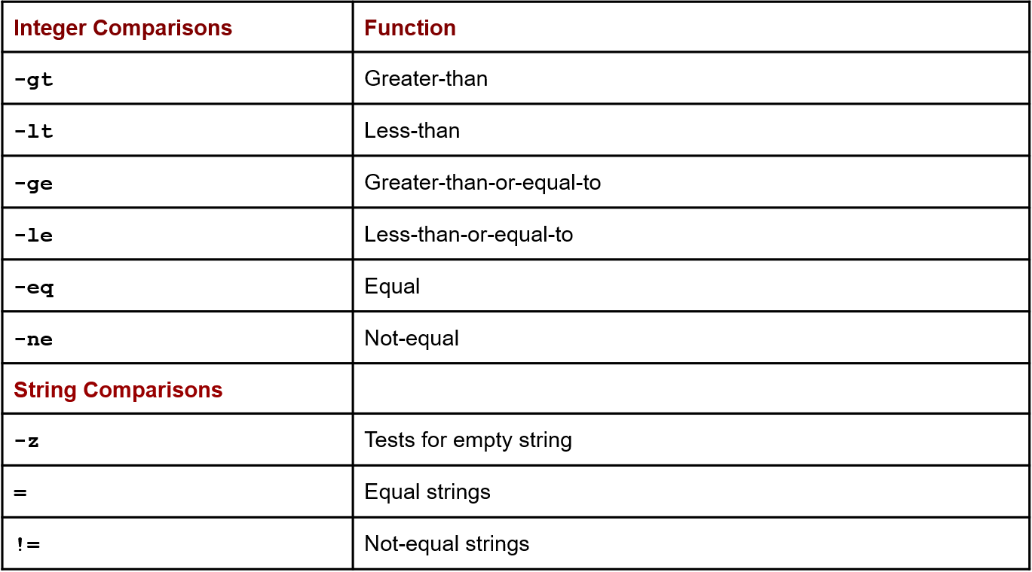

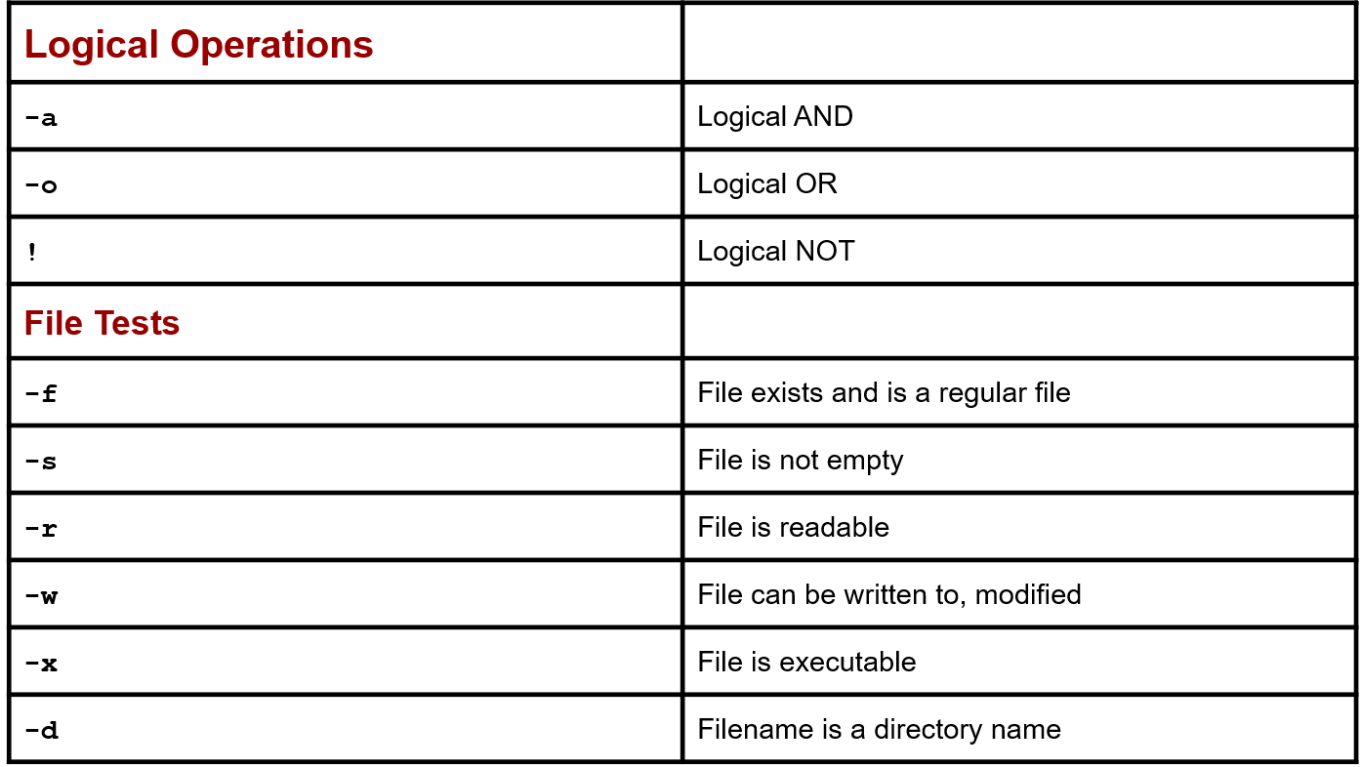

**CONDITION CONTROL STRUCTURES**

These conditional control structures differ from those found in programming languages by:

The if condition tests the success of a Linux command, not an expression.

The end of an if-then command must be indicated with the keyword fi, and the end of a case command is indicated with the keyword esac.

The if structure places a condition on commands. That condition is the exit status of a specific Linux command.

If a command is successful, returning an exit status of 0, then the commands within the if structure are executed. If the exit status is anything other than 0, then the command has failed and the commands within the if structure are not executed.

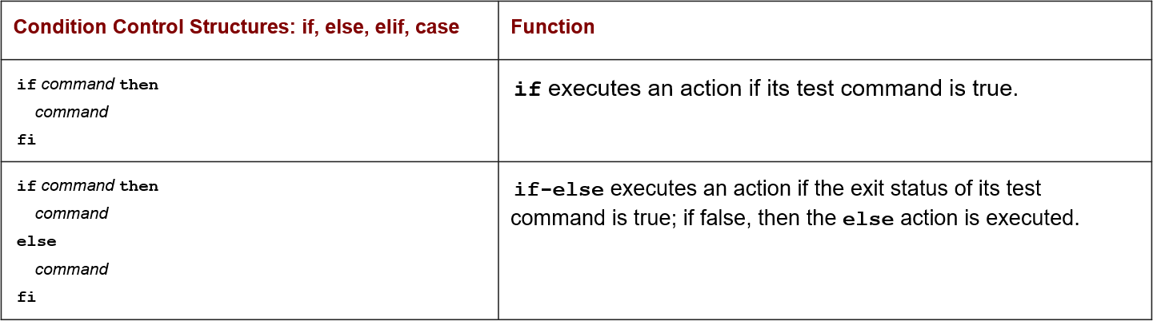

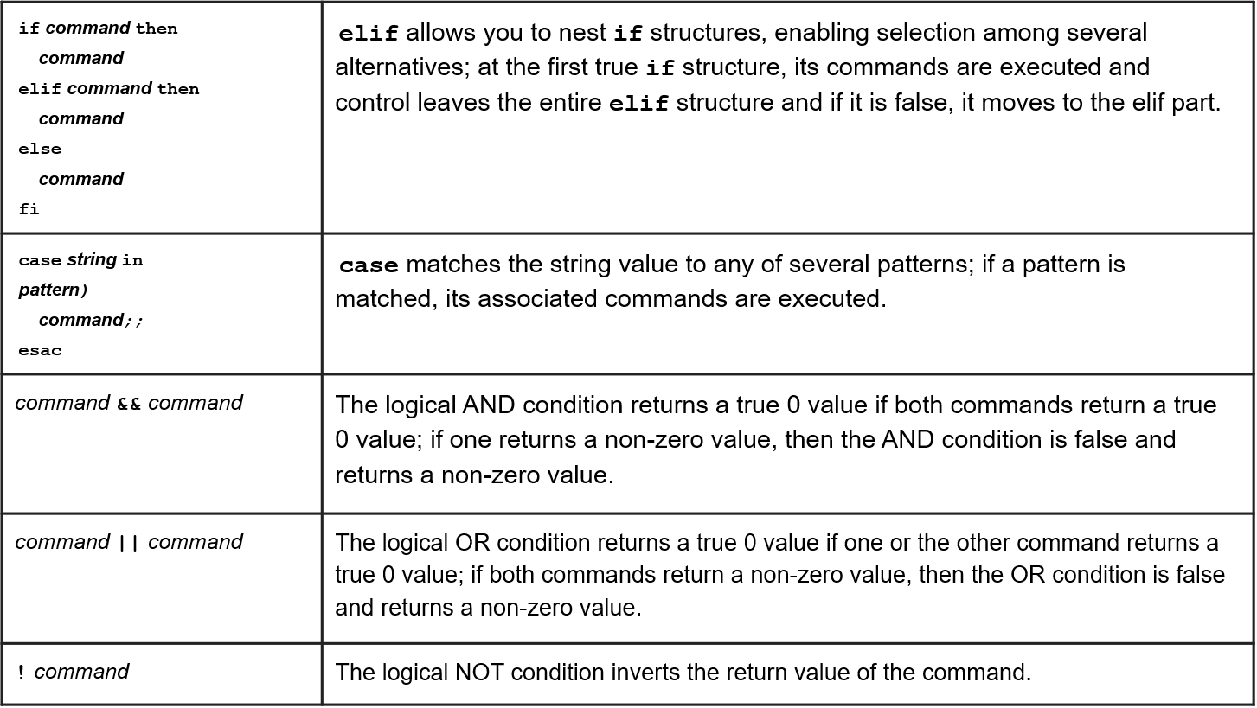

**LOOP CONTROL STRUCTURES**

* The while loop repeats commands. A while loop begins with the keyword while and is followed by a command.
* The keyword do follows on the next line. The end of the loop is specified by the keyword done.
* The Linux command used in while structures is often a test command indicated by enclosing brackets.
* The for-in structure is designed to reference a list of values sequentially. It takes two operands—a variable and a list of values. The values in the list are assigned one by one to the variable in the for-in structure.
* Like the while command, the for-in structure is a loop. Each time through the loop, the next value in the list is assigned to the variable. When the end of the list is reached, the loop stops.
* Like the while loop, the body of a for-in loop begins with the keyword do and ends with the keyword done.

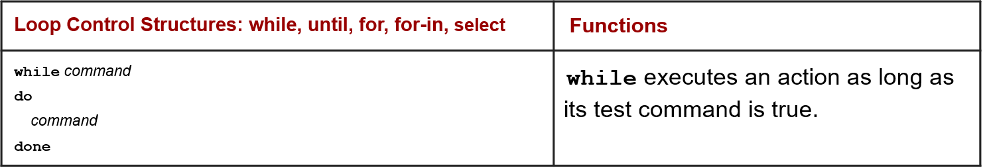

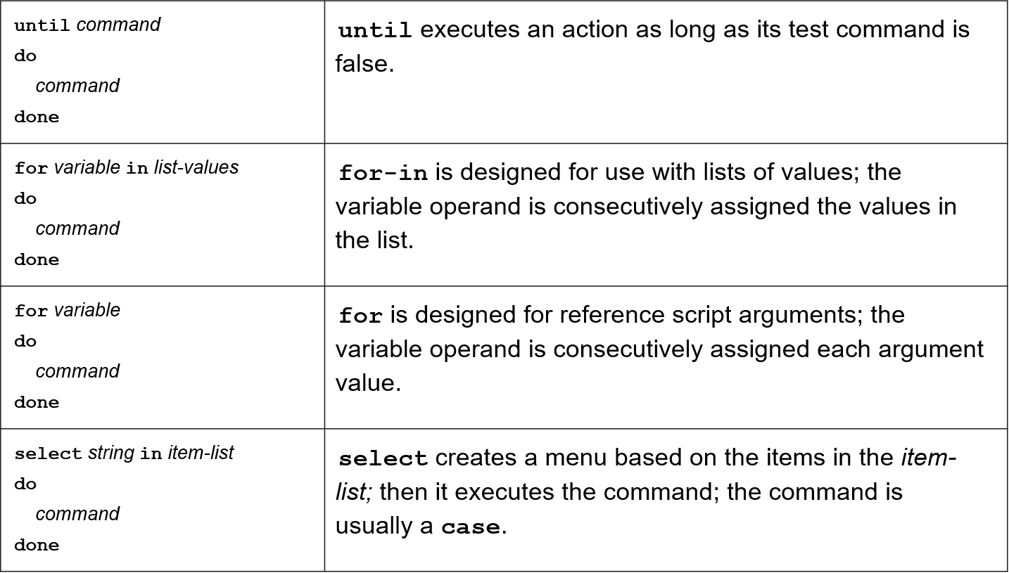

**Starting VI**

* vi filename: Creates a new file if it already not exist, otherwise opens existing file.
* vi -R filename : Opens an existing file in read only mode.
* view filename : Opens an existing file in read only mode*.*

**Three modes of VI Editor :**

* **Command Mode**: When vi starts up, it is in Command Mode. This mode is where vi interprets any characters we type as commands and thus does not display them in the window. This mode allows us to move through a file, and to delete, copy, or paste a piece of text.
* **Insert mode**: This mode enables you to insert text into the file. Everything that’s typed in this mode is interpreted as input and finally, it is put in the file.
* **Last Line Mode(Escape Mode):** Line Mode is invoked by typing a colon [:], while vi is in Command Mode. The cursor will jump to the last line of the screen and vi will wait for a command. This mode enables you to perform tasks such as saving files, executing commands.

**Moving within a File(Navigation):(in Command Mode)**

To move around within a file without affecting text , used to move around one character at a time.

Commands and their Description

•k : Moves the cursor up one line.

•j : Moves the cursor down one line.

•h : Moves the cursor to the left one character position.

•l : Moves the cursor to the right one character position.

•0 or | : Positions cursor at beginning of line.

•$ : Positions cursor at end of line.

•W : Positions cursor to the next word.

•B : Positions cursor to previous word.

•( : Positions cursor to beginning of current sentence.

•) : Positions cursor to beginning of next sentence.

•H : Move to top of screen.

•nH : Moves to nth line from the top of the screen.

•M : Move to middle of screen.

•L : Move to bottom of screen.

•nL : Moves to nth line from the bottom of the screen.

•colon along with x : Colon followed by a number would position the cursor on line number represented by x.

**Editing and inserting in Files(Entering and Replacing Text):** (Command Mode->Insert Mode)

•**i** : Inserts text before current cursor location.

•**I** : Inserts text at beginning of current line.

•**a** : Inserts text after current cursor location.

•**A : Inserts text at end of current line.**

•**o** : Creates a new line for text entry below cursor location.

•**O** : Creates a new line for text entry above cursor location.

•**r** : Replace single character under the cursor with the next character typed.

•**R** : Replaces text from the cursor to right.

•**s** : Replaces single character under the cursor with any number of characters.

•**S** :Replaces entire line.

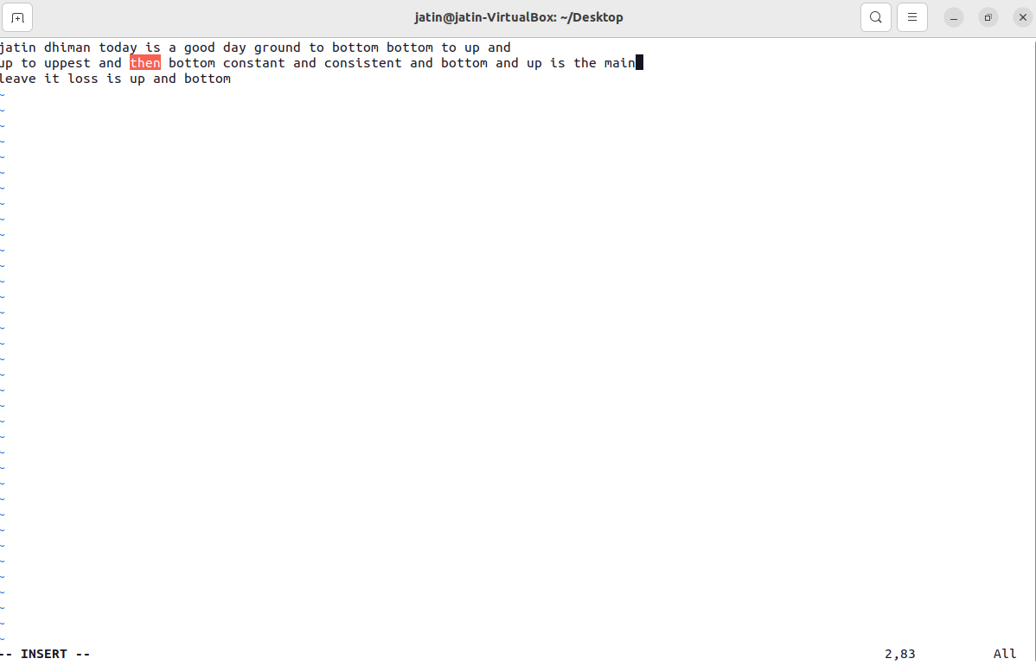

**Deleting Characters:**

•**X** Uppercase: Deletes the character before the cursor location.(backspace)

•**x** Lowercase : Deletes character at the cursor location.

•**Dw** : Deletes from the current cursor location to the next word(includes white space also).

•**d^** : Deletes from current cursor position to the beginning of the line.

•**d$** : Deletes from current cursor position to the end of the line.

•**Dd** : Deletes the line the cursor is on the.

d^ demonstration:





**Copy(yank) and Paste Commands:**

•**Yy** : Copies the current line.

•**9yy** : Yank current line and 9 lines below it.

•**p** : Puts the copied text after the cursor.

•**P** : Puts the yanked text before the cursor.

**Searching and Replacing in (ex Mode):**

* **vi** also has powerful search and replace capabilities. The formal syntax for searching is:

**:s/string**

* The syntax for replacing one string with another string in the current line is:

**:s/pattern/replace/**

* The syntax for replacing every occurrence of a string in the entire text is similar. The only difference is the addition of a “%” in front of the “s”:

**:%s/pattern/replace/**

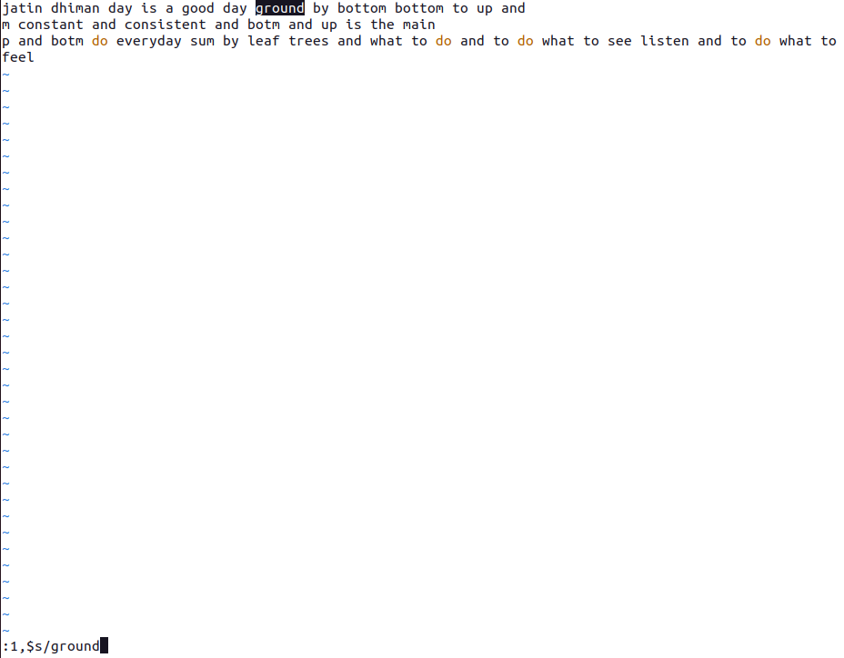

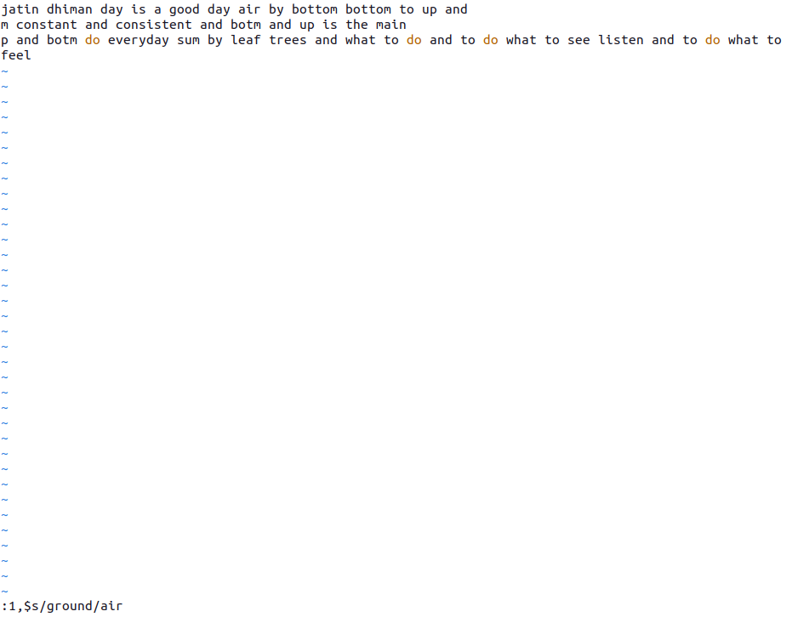

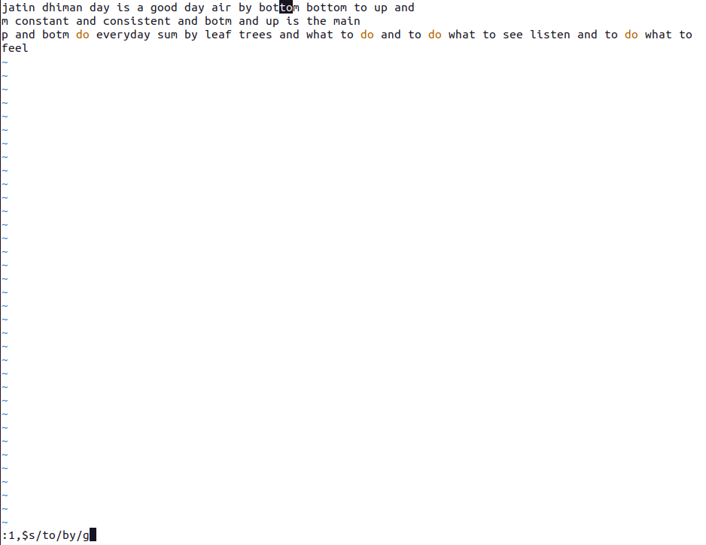

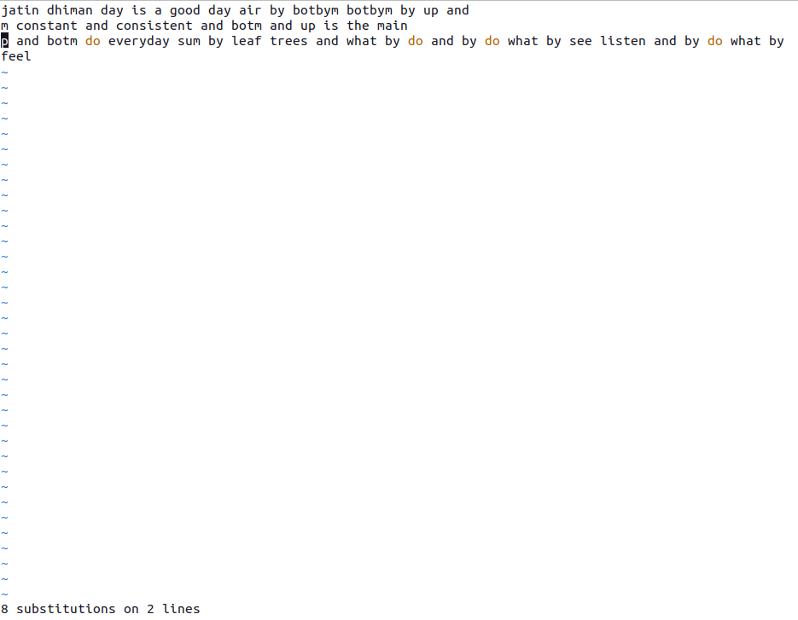

**Save and Exit Commands of the last line Mode**

Insert mode-> press esc -> command mode-> press “:” -> last line mode-> type following command

•**q** : Quit

•**q!** : Quit without saving changes i.e. discard changes.

•**r fileName** : Read data from file called fileName.

•**wq** : Write and quit (save and exit).

•**w fileName** : Write to file called fileName (save as).

•**w! fileName** : Overwrite to file called fileName (save as forcefully).

•**!cmd** : Runs shell commands and returns to Command mode.

•Eg: “:! ls”



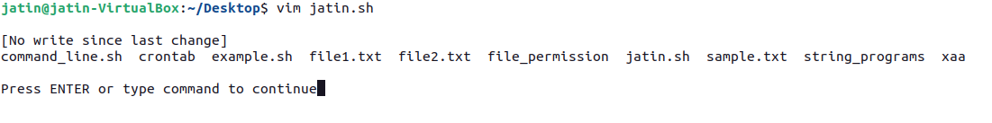

* **Command Line Arguments**

Command line arguments, also known as positional parameters allow the users to either control the flow of the command or to specify the input data for the command. These arguments are specific with the shell script on terminal during the run time.

Syntax:

**$ bash filename.sh argument1 argument2 ... argumentN**

Where,

Filename.sh is a shell script file,

argument1, argument2 ... argumentN are list of arguments.

**Example: $ bash greetings.sh Hello World**

In the above example, greetings.sh is the script file. Hello and World are the arguments

See the below image to understand the command line values and variables. Here ARG1, ARG2 to ARG10 are command line values, which is assigned to corresponding shell variables.

**Special variables**

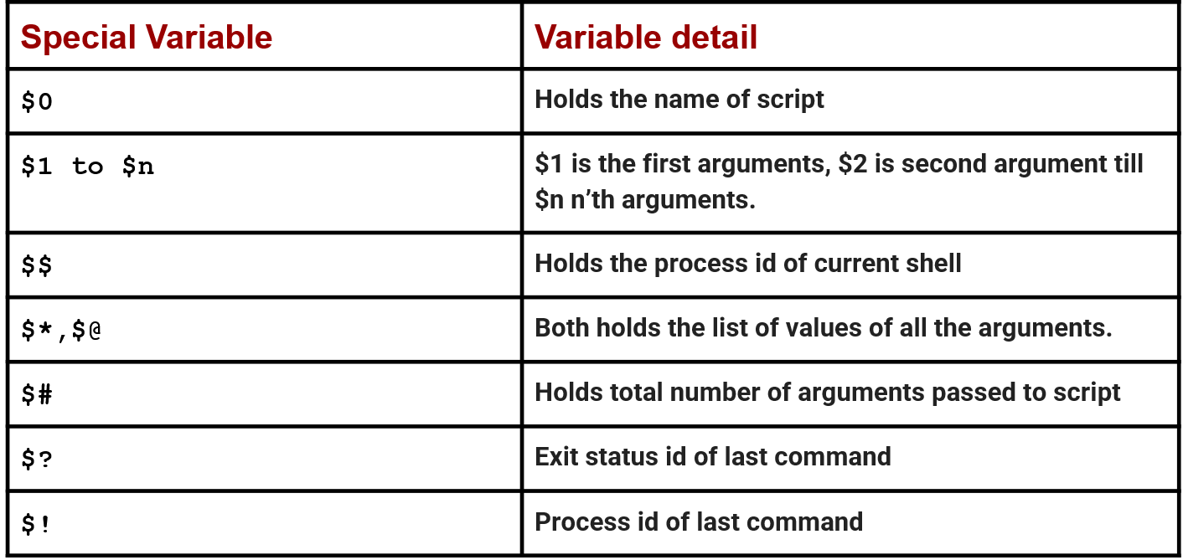

**Demonstrating command line arguments**

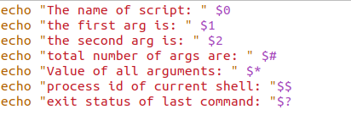

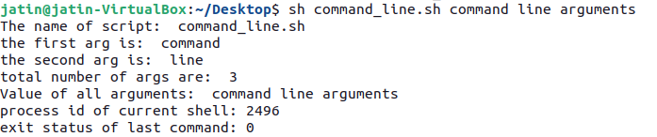

**Positioning Command Arguments**

**1. set**

This command can be used to set the values of the positional parameters on the command line.

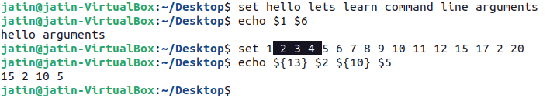

**2. shift**

The shift command is used to move command line arguments by one position i.e. $2 will be shifted to $1 all the way to the tenth parameter being shifted to $9.

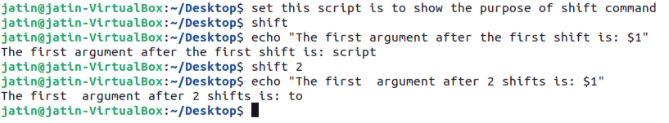

**Practical:- 7**

**Shell Scripting Programs**

1. **Addition of two numbers**

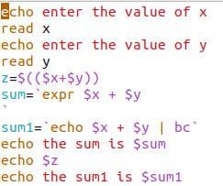

**Output:**

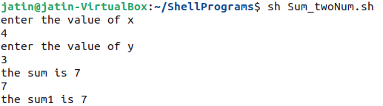

1. **Check whether the number entered is odd/even**

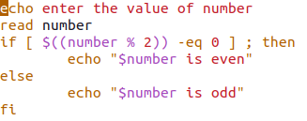

**Output:**

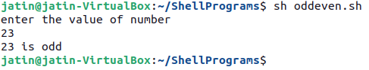

1. **Check whether the year is leap or not**

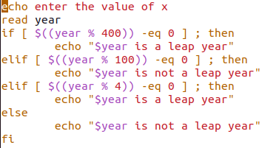

**Output:**

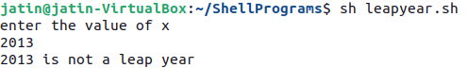

1. **To find circumference and area of circle**

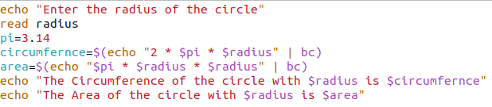

**Output:**

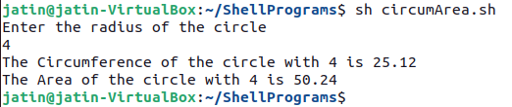

1. **To find the sum of digits of a number**

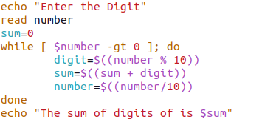

**Output:**

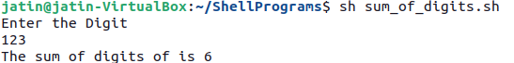

1. **Find the factorial of a number**

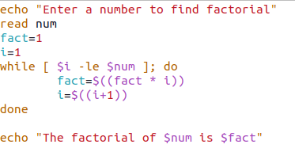

**Output:**

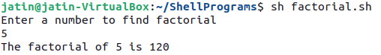

1. **Find the fibonacci series**

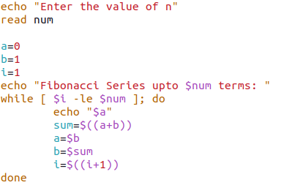

**Output:**

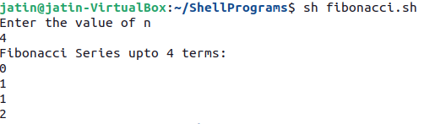

1. **Check whether a number is prime or not**

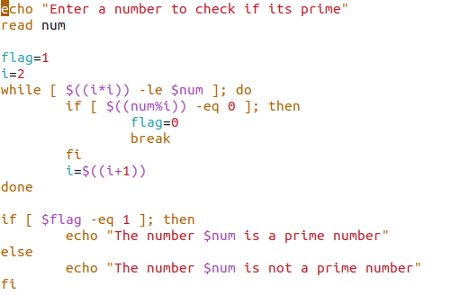

**Output:**

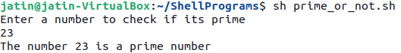

1. **Check whether the number is palindrome or not**

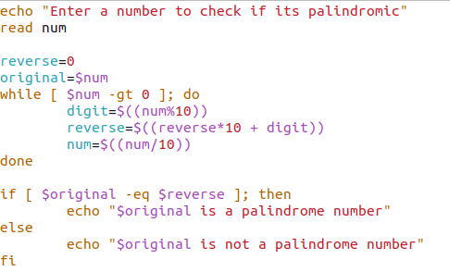

**Output:**

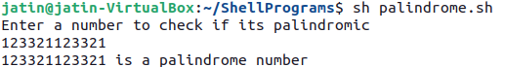

1. **Reverse of a given number**

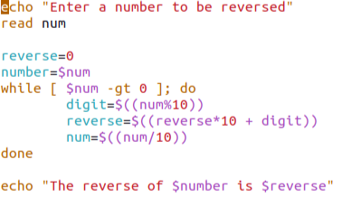

**Output:**

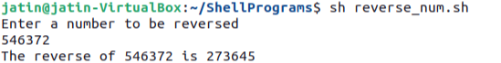

1. **To create a binary calculator using switch case**

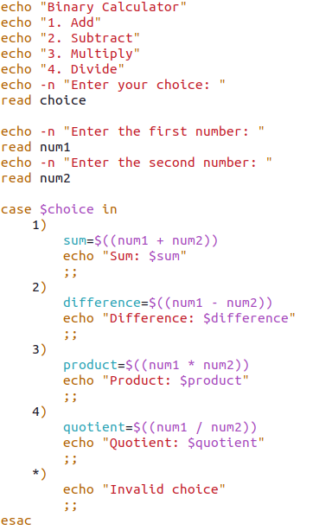

**Output:**

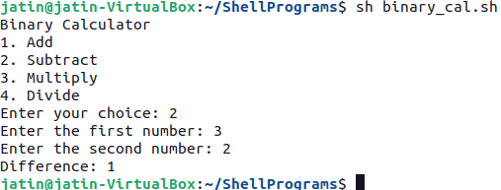

**Practical:- 8**

**STRING OPERATIONS PROGRAMS IN VIM EDITOR**

1. **Find the length of string**

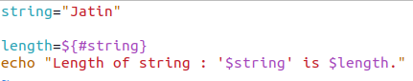

**Output:**



1. **Compare two Strings**

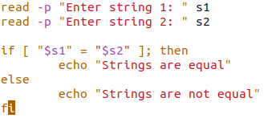

**Output:**

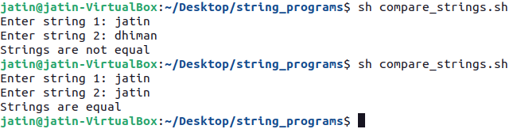

1. **Reverse of a string**

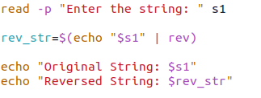

**Output:**

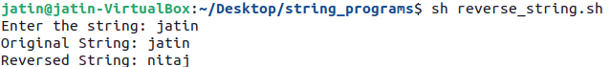

1. **String is palindrome or not**

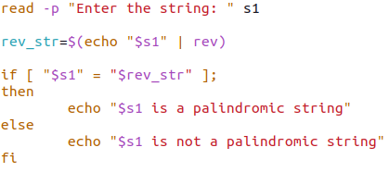

**Output:**

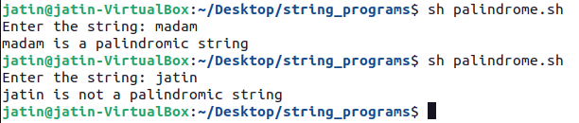

1. **Occurrence of a pattern**

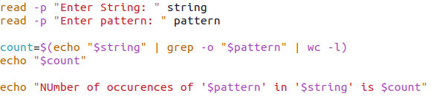

**Output:**

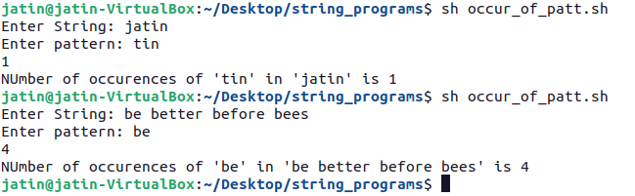

1. **Concatenate strings**

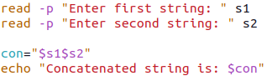

**Output:**

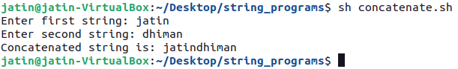

1. **Convert lowercase letters into uppercase**

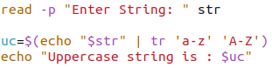

**Output:**

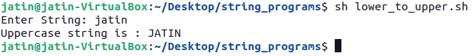

**Practical:- 9**

**TO IMPLEMENT THE FOLLOWING FILE OPERATIONS IN VIM EDITOR**

**1. To see permissions of a file after checking whether it is file or directory**

**Code:**

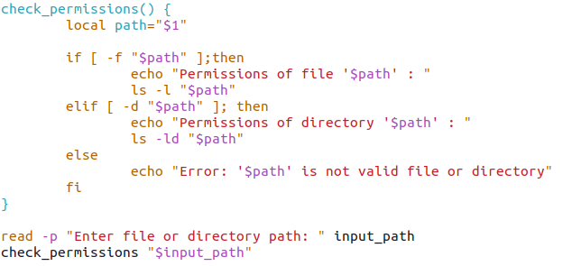

**Output:**

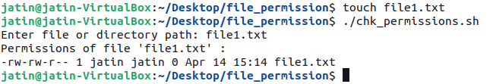

**2. Rename file**

**Code:**

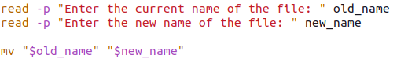

**Output:**

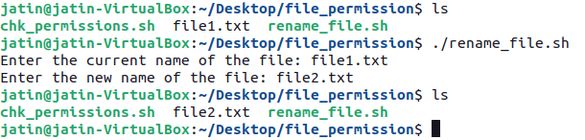

**3. Take backup of a directory**

**Code:**



**Output:**

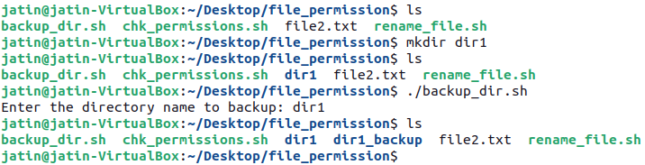

**4. Compare directories and delete duplicate files**

**Code:**

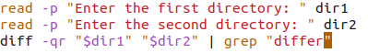

**Output:**

**5. To Check the number of files through command line arguments**

**Code1:**

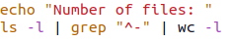

**Output1:**

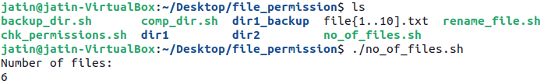

**Code2:**



**Output2:**



**6. If number of files is even, then copy first argument in second and so on, else display odd**

**Code:**

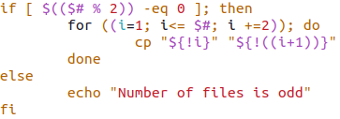

**Output:**

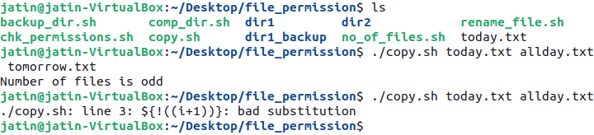

**7. Number of arguments**

**Code:**



**Output:**



**8. Convert lowercase letters into upper case**

**Code:**

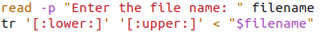

**Output:**

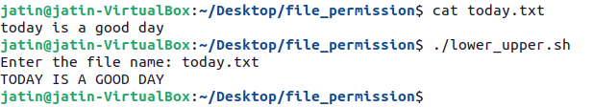

**9. To calculate length of a file**

**Code:**

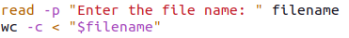

**Output:**

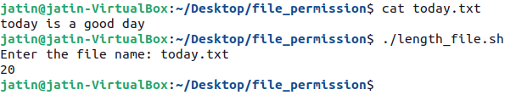

**Practical:- 10**

**WRITE C++ PROGRAMS TO IMPLEMENT CPU SCHEDULING ALGORITHMS:**

* **FIRST COME FIRST SERVE**
* **SHORTEST JOB FIRST (P,NP)**
* **PRIORITY BASED SCHEDULING (P,NP)**
* **ROUND ROBIN**
* **FCFS**

**Code:**

pair<int, vector<PCB>> FCFS(vector<PCB> &process_list)

{

    sort_arrival_time_then_id(process_list);

    int time = 0;

    cout << "0 | ";

    for (auto &current_process : process_list)

    {

        time += current_process.burst_time;

        cout << "P" << current_process.process_id << " | " << time << " | ";

        current_process.completion_time = time;

        current_process.turnaround_time = current_process.completion_time - current_process.arrival_time;

        current_process.waiting_time = current_process.turnaround_time - current_process.burst_time;

    }

    cout << endl;

    return {time, process_list};

}

**Output:**

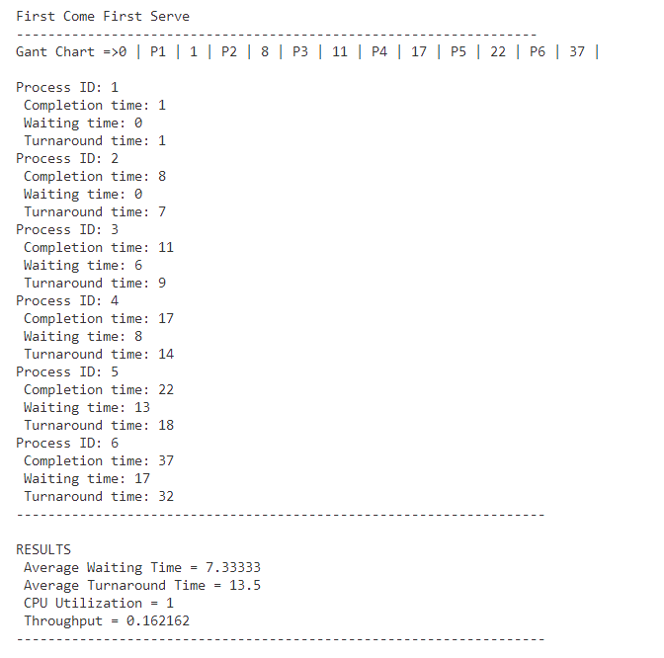

* **SJF NON-PREMPTIVE**

**Code:**

pair<int, vector<PCB>> SJF_Non_premptive(vector<PCB> &process_list)

{

    int time = 0;

    cout << "0 | ";

    deque<PCB> remain_processes(process_list.begin(), process_list.end());

    while (!remain_processes.empty())

    {

        sort_on_sjf(remain_processes, time);

        PCB current_process = remain_processes.front();

        remain_processes.pop_front();

        time += current_process.burst_time;

        cout << "P" << current_process.process_id << " | " << time << " | ";

        int id = current_process.process_id;

        int index = -1;

        for (int i = 0; i < process_list.size(); i++)

        {

            if (id == process_list[i].process_id)

            {

                index = i;

                break;

            }

        }

        process_list[index].completion_time = time;

        process_list[index].turnaround_time = process_list[index].completion_time - process_list[index].arrival_time;

        process_list[index].waiting_time = process_list[index].turnaround_time - process_list[index].burst_time;

    }

    cout << endl;

    return {time, process_list};

}

**Output:**

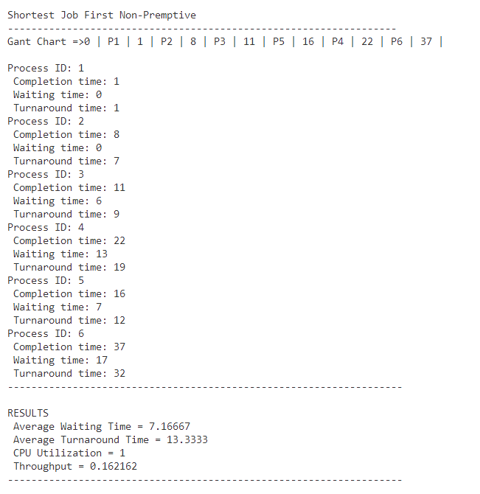

* **SJF PREMPTIVE**

**Code:**

pair<int, vector<PCB>> SJF_premptive(vector<PCB> &process_list)

{

    int time = 0;

    cout << "0 | ";

    deque<PCB> remain_processes(process_list.begin(), process_list.end());

    while (!remain_processes.empty())

    {

        sort_on_sjf(remain_processes, time);

        PCB current_process = remain_processes.front();

        current_process.remaining_burst -= 1;

        remain_processes.pop_front();

        time += 1;

        cout << "P" << current_process.process_id << " | " << time << " | ";

        int id = current_process.process_id;

        int index = -1;

        for (int i = 0; i < process_list.size(); i++)

        {

            if (id == process_list[i].process_id)

            {

                index = i;

                break;

            }

        }

        if (current_process.remaining_burst > 0)

        {

            remain_processes.push_back(current_process);

        }

        else

        {

            process_list[index].completion_time = time;

            process_list[index].turnaround_time = process_list[index].completion_time - process_list[index].arrival_time;

            process_list[index].waiting_time = process_list[index].turnaround_time - process_list[index].burst_time;

        }

    }

    cout << endl;

    return {time, process_list};

}

**Output:**

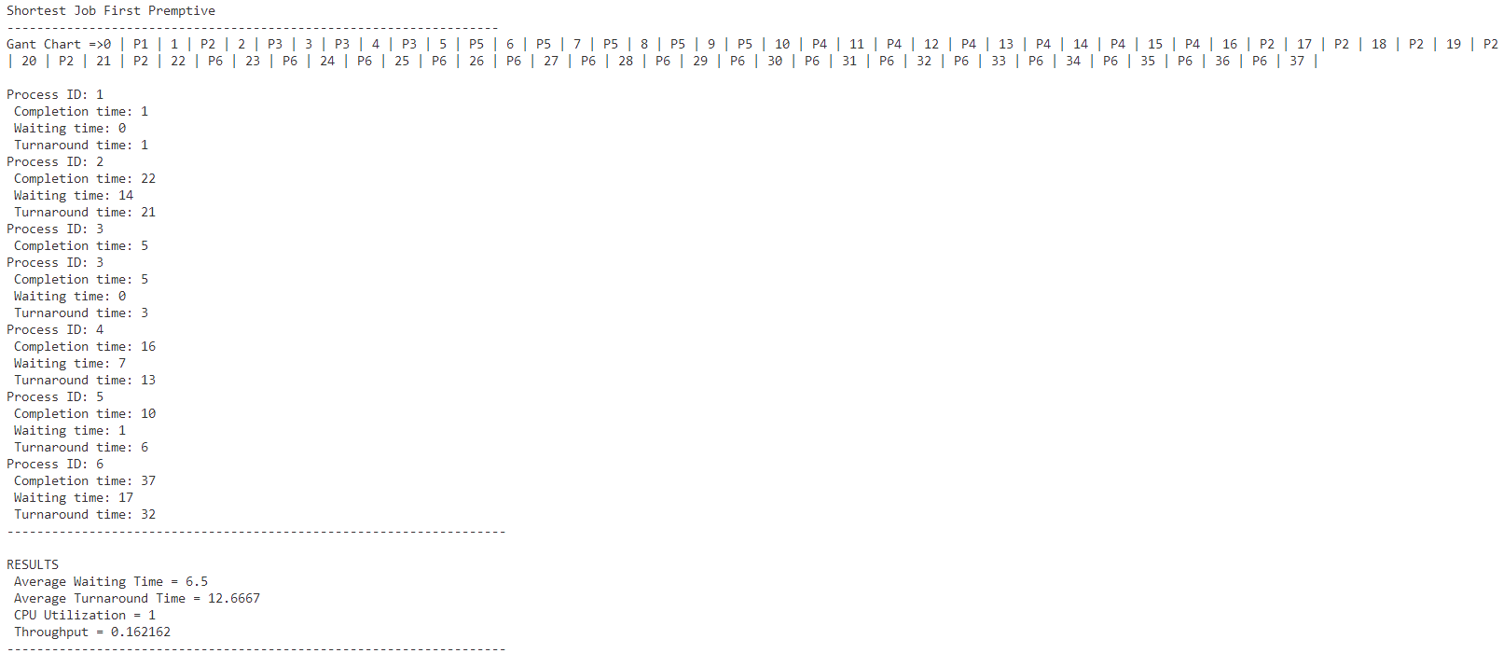

* **PRIORITY NON-PREMPTIVE**

**Code:**

pair<int, vector<PCB>> priority_Non_Premptive(vector<PCB> &process_list)

{

    deque<PCB> remaining_process(process_list.begin(), process_list.end());

    int time = 0;

    cout << "0 |";

    while (!remaining_process.empty())

    {

        sort_priority(remaining_process, time);

        PCB curr_process = remaining_process.front();

        remaining_process.pop_front();

        time += curr_process.burst_time;

        cout << "P" << curr_process.process_id << " | " << time << " | ";

        int id = curr_process.process_id;

        int index = -1;

        for (int i = 0; i < process_list.size(); i++)

        {

            if (id == process_list[i].process_id)

            {

                index = i;

                break;

            }

        }

        process_list[index].completion_time = time;

        process_list[index].turnaround_time = process_list[index].completion_time - process_list[index].arrival_time;

        process_list[index].waiting_time = process_list[index].turnaround_time - process_list[index].burst_time;

    }

    cout << endl;

    return {time, process_list};

}

**Output:**

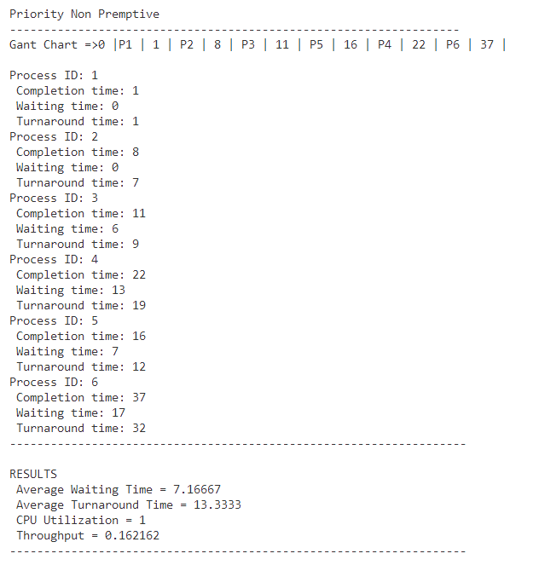

* **PRIORITY PREMPTIVE**

**Code:**

pair<int, vector<PCB>> priority_Premptive(vector<PCB> &process_list)

{

    // checking change of parameters every second

    int time = 0;

    cout << "0 | ";

    deque<PCB> remain_processes(process_list.begin(), process_list.end());

    while (!remain_processes.empty())

    {

        sort_priority(remain_processes, time);

        PCB current_process = remain_processes.front();

        current_process.remaining_burst -= 1;

        remain_processes.pop_front();

        time += 1;

        cout << "P" << current_process.process_id << " | " << time << " | ";

        if (current_process.remaining_burst > 0)

        {

            remain_processes.push_back(current_process);

        }

        else

        {

            int id = current_process.process_id;

            int index = -1;

            for (int i = 0; i < process_list.size(); i++)

            {

                if (id == process_list[i].process_id)

                {

                    index = i;

                    break;

                }

            }

            process_list[index].completion_time = time;

            process_list[index].turnaround_time = process_list[index].completion_time - process_list[index].arrival_time;

            process_list[index].waiting_time = process_list[index].turnaround_time - process_list[index].burst_time;

        }

    }

    cout << endl;

    return {time, process_list};

}

**Output:**

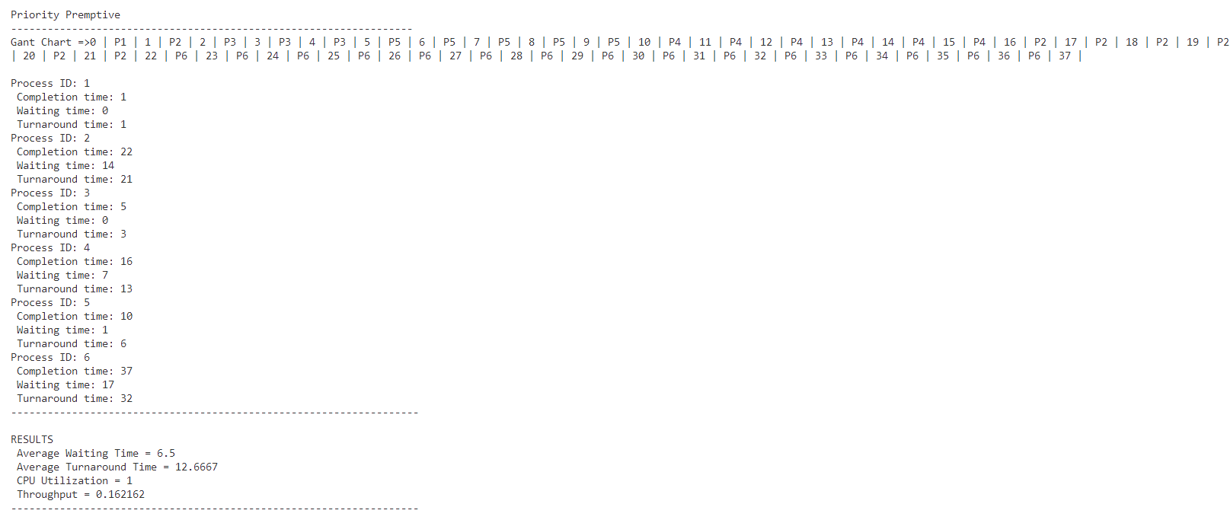

* **ROUND ROBIN**

**Code:**

pair<int, vector<PCB>> round_robin(vector<PCB> &process_list, int quantum)

    {

        int n = process_list.size();

        int time = 0;

        int completedProcesses = 0;

        sort_arrival_time_then_id(process_list);

        deque<PCB> q; // Queue for ready processes

        int i = 0; // Index to track the current process

        cout<<" 0 |";

        while (completedProcesses < n)

        {

            // Add processes that have arrived before or at the current time to the queue

            while (i < n && process_list[i].arrival_time <= time)

            {

                q.push_back(process_list[i]);

                i++;

            }

            if (q.empty())

            {

                // If no process is in the ready queue, jump to the next arrival time

                time = process_list[i].arrival_time;

                continue;

            }

            PCB current_process = q.front();

            q.pop_front();

            // Execute the process for the quantum time or remaining burst time, whichever is smaller

            int executeTime = min(quantum, current_process.remaining_burst);

            time += executeTime;

            cout << "P" << current_process.process_id << " | " << time << " | ";

            current_process.remaining_burst -= executeTime;

            // Add processes that have arrived during the execution of the current process

            while (i < n && process_list[i].arrival_time <= time)

            {

                q.push_back(process_list[i]);

                i++;

            }

            if (current_process.remaining_burst > 0)

            {

                // If the process still has remaining burst time, re-add it to the queue

                q.push_back(current_process);

            }

            else

            {

                // Process has completed

                int id = current_process.process_id;

                int index = -1;

                for (int j = 0; j < process_list.size(); j++)

                {

                    if (id == process_list[j].process_id)

                    {

                        index = j;

                        break;

                    }

                }

                process_list[index].completion_time = time;

                process_list[index].turnaround_time = process_list[index].completion_time - process_list[index].arrival_time;

                process_list[index].waiting_time = process_list[index].turnaround_time - process_list[index].burst_time;

                completedProcesses++;

            }

        }

        return {time, process_list};

    }

**Output:**

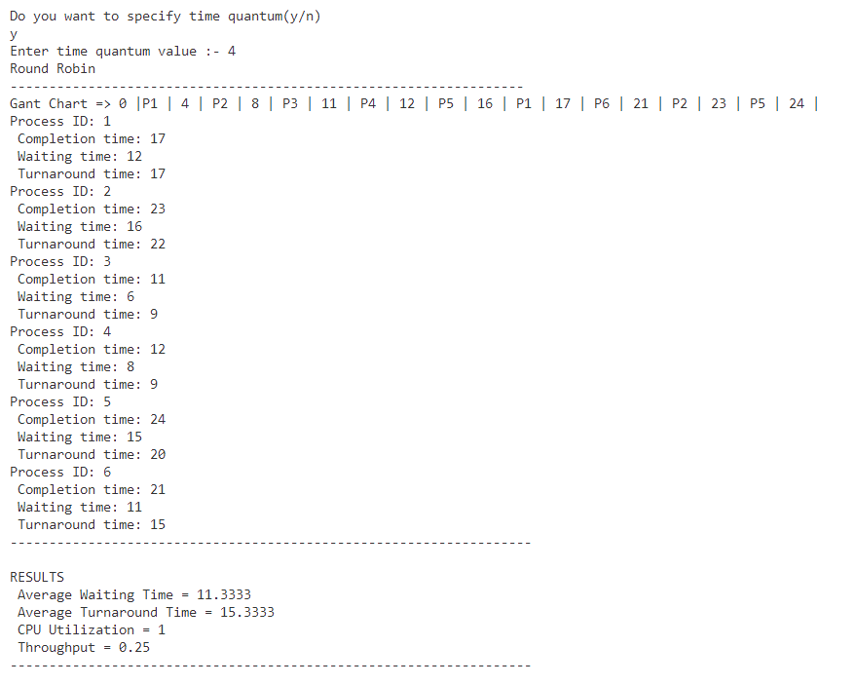

**Practical:- 11**

**C++ PROGRAMMING TO IMPLEMENT BANKER’S ALGORITHM**

* **SAFETY ALGORITHM**
* **REQUEST AND RESOURCE ALLOCATION**

**Code:**

#include <iostream>

#include <vector>

using namespace std;

class process_info

{

public:

    int process_id;

    vector<int> max_need;

    vector<int> allocated;

    vector<int> need;

    process_info(int process_id, int no_of_resources)

    {

        this->process_id = process_id;

        max_need.resize(no_of_resources);

        allocated.resize(no_of_resources);

        need.resize(no_of_resources);

        cout << "Enter the max need of resources for process P" << process_id << ": ";

        for (int i = 0; i < no_of_resources; i++)

        {

            cin >> max_need[i];

        }

        cout << "Enter the no. of already allocated resources to process P" << process_id << ": ";

        for (int i = 0; i < no_of_resources; i++)

        {

            cin >> allocated[i];

        }

        for (int i = 0; i < no_of_resources; i++)

        {

            need[i] = max_need[i] - allocated[i];

        }

    }

};

class banker

{

public:

    vector<process_info> process_details;

    vector<int> available;

    int no_of_process;

    int no_of_resources;

    banker()

    {

        cout << "Enter the number of process: ";

        cin >> no_of_process;

        cout << "Enter the no. of instances of resource: ";

        cin >> no_of_resources;

        for (int i = 0; i < no_of_process; i++)

        {

            process_info process(i, no_of_resources);

            process_details.push_back(process);

        }

        available.resize(no_of_resources);

        cout << "Enter the available number of instances for each resource " << endl;

        for (int i = 0; i < no_of_resources; i++)

        {

            cin >> available[i];

        }

    }

    bool safety_algorithm()

    {

        vector<bool> finish(no_of_process, false);

        vector<int> safe_sequence;

        for (int k = 0; k < no_of_process; k++)

        {

            for (int i = 0; i < no_of_process; i++)

            {

                if (finish[i] == false)

                {

                    bool flag = false;

                    for (int j = 0; j < no_of_resources; j++)

                    {

                        if (process_details[i].need[j] > available[j])

                        {

                            flag = true;

                            break;

                        }

                    }

                    if (flag == false)

                    {

                        safe_sequence.push_back(i);

                        for (int p = 0; p < no_of_resources; p++)

                        {

                            available[p] += process_details[i].allocated[p];

                        }

                        finish[i] = true;

                    }

                }

            }

        }

        bool flag = true;

        for (int i = 0; i < no_of_process; i++)

        {

            if (finish[i] == 0)

            {

                flag = false;

                cout << "The given sequence is not safe\n";

                return false;

                break;

            }

        }

        if (flag == true)

        {

            cout << "Safe Sequence is :- " << endl;

            for (int i = 0; i <= no_of_process - 2; i++)

            {

                cout << "P" << safe_sequence[i] << " -> ";

            }

            cout << "P" << safe_sequence[no_of_process - 1] << endl;

            return true;

        }

    }

    bool requestResourceAllocation()

    {

        vector<int> request(no_of_resources);

        int id;

        cout << "Enter the id of process which made request (0-" << no_of_process - 1 << "): ";

        cin >> id;

        cout << "Enter the Requested resource instances: ";

        for (int i = 0; i < no_of_resources; i++)

        {

            cin >> request[i];

        }

        for (int i = 0; i < no_of_resources; i++)

        {

            if (process_details[id].need[i] < request[i] && request[i] > available[i])

            {

                return false;

            }

        }

        for (int i = 0; i < no_of_resources; i++)

        {

            available[i] -= request[i];

            process_details[id].allocated[i] += request[i];

            process_details[id].need[i] -= request[i];

        }

        if (safety_algorithm())

        {

            cout<<"Request Granted"<<endl;

            return true;

        }

        else

        {

            cout<<"Request Denied"<<endl;

            return false;

        }

    }

};

int main()

{

    banker b;

    b.safety_algorithm();

    cout<<endl;

    b.requestResourceAllocation();

    return 0;

}

**Output:**

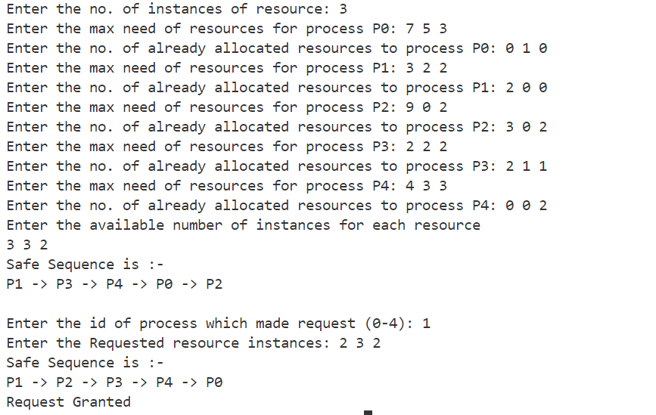

**Practical:- 12**

**WRITE A C++ PROGRAM TO IMPLEMENT THE FOLLOWING PROCESS SYNCHRONISATION ALGORITHMS WITH SEMAPHORES :**

**1. Producer Consumer Problem**

**Code:**

#include <iostream>

#include <queue>

#include <pthread.h>

#include <semaphore.h>

#include <unistd.h> // For sleep()

using namespace std;

const int MaxBufferSize = 5;

static int size = 0;

queue<int> buffer;

sem_t mutex, empty, full;

void* producer(void* arg) {

    int item;

    while (true) {

        item = rand() % 100; // Generate a random item

        sem_wait(&empty);    // Wait if buffer is full

        sem_wait(&mutex);    // Wait for access to buffer

        buffer.push(item);

        size++;

          // Produce item and add to buffer

        cout << "Produced: " << item << endl;

         cout<<"current size: "<<size<<endl;

        sem_post(&mutex);    // Release access to buffer

        sem_post(&full);     // Signal that buffer is not empty

        sleep(1);            // Sleep to simulate production time

    }

}

void* consumer(void* arg) {

    int item;

    while (true) {

        sem_wait(&full);     // Wait if buffer is empty

        sem_wait(&mutex);    // Wait for access to buffer

        item = buffer.front(); // Consume item from buffer

        buffer.pop();

        size--;

        cout << "Consumed: " << item << endl;

        cout<<"current size: "<<size<<endl;

        sem_post(&mutex);    // Release access to buffer

        sem_post(&empty);    // Signal that buffer is not full

        sleep(1);            // Sleep to simulate consumption time

    }

}

int main() {

    pthread_t producerThread, consumerThread;

    // Initialize semaphores

    sem_init(&mutex, 0, 1);

    sem_init(&empty, 0, MaxBufferSize);

    sem_init(&full, 0, 0);

    // Create producer and consumer threads

    pthread_create(&producerThread, NULL, producer, &size);

    pthread_create(&consumerThread, NULL, consumer, &size);

    // Join threads

    pthread_join(producerThread, NULL);

    pthread_join(consumerThread, NULL);

    // Destroy semaphores

    sem_destroy(&mutex);

    sem_destroy(&empty);

    sem_destroy(&full);

    return 0;

}

**Output:**

PS E:\osAlgos\semaphores> g++ -pthread ProducerConsumer.cpp

PS E:\osAlgos\semaphores> ./a.exe

Produced: 41

current size: 1

Consumed: 41

current size: 0

Produced: 67

current size: 1

Consumed: 67

current size: 0

Produced: 34

current size: 1

Consumed: 34

current size: 0

Produced: 0

current size: 1

Consumed: 0

current size: 0

Produced: 69

current size: 1

Consumed: 69

current size: 0

Produced: 24

current size: 1

Consumed: 24

current size: 0

**2. Readers writers Problem**

**Code:**

#include <iostream>

#include <queue>

#include <pthread.h>

#include <semaphore.h>

#include <unistd.h> // For sleep()

using namespace std;

queue<int> readBuffer;

queue<int> buffer;

sem_t mutex, write_sem;

void* reader(void* arg) {

    int item;

    while (true) {

        int id = rand() % 100;

        sem_wait(&mutex); // Wait for access to buffer

        readBuffer.push(id);

        cout << "reader enters" << endl;

        if (readBuffer.size() == 1) {

            sem_wait(&write_sem);

        }

        cout << "total readers : " << readBuffer.size() << endl;

        readBuffer.pop();

        if (readBuffer.size() == 0)

            sem_post(&write_sem);

        sem_post(&mutex);

        cout << "reader exit" << endl;

        cout << "total readers after realizing one : " << readBuffer.size() << endl;

        sleep(1); // Sleep to simulate production time

    }

}

void* writer(void* arg) {

    while (true) {

        sem_wait(&write_sem); // Wait for access to buffer

        cout << "writer is working" << endl;

        sem_post(&write_sem);

        cout << "writer exit" << endl;

        sleep(1); // Sleep to simulate consumption time

    }

}

int main() {

    pthread_t writerThread, readerThread;

    sem_init(&mutex, 0, 1);        // Initialize mutex to 1

    sem_init(&write_sem, 0, 1);    // Initialize write semaphore to 1

    // Create reader and writer threads

    pthread_create(&readerThread, NULL, reader, NULL);

    pthread_create(&writerThread, NULL, writer, NULL);

    // Join threads

    pthread_join(readerThread, NULL);

    pthread_join(writerThread, NULL);

    // Destroy semaphores

    sem_destroy(&mutex);

    sem_destroy(&write_sem);

    return 0;

}

**Output:**

PS E:\osAlgos\semaphores> ./a.exe

writer is workingreader enters

total readers : writer exit

1

reader exit

total readers after realizing one : 0

writer is working

writer exit

reader enters

total readers : 1

reader exit

total readers after realising one : 0

writer is working

writer exit

reader enters

total readers : 1

reader exit

total readers after realising one : 0

writer is working

writer exit

reader enters

total readers : 1

reader exit

total readers after realising one : 0

writer is working

writer exit

reader enters

total readers : 1

reader exit

total readers after realising one : 0

**3. Dining Philospher problem**

**Code:**

#include<iostream>

#include <pthread.h>

#include <semaphore.h>

#include<unistd.h>

using namespace std;

#define N 5

#define THINKING 2

#define HUNGRY 1

#define EATING 0

#define LEFT (philosopherNumber + 4) % N

#define RIGHT (philosopherNumber + 1) % N

int state[N];

int phil[N] = { 0, 1, 2, 3, 4 };

sem_t mutex;

sem_t S[N];

void test(int philosopherNumber)

{

    if (state[philosopherNumber] == HUNGRY && state[LEFT] != EATING && state[RIGHT] != EATING) {

        state[philosopherNumber] = EATING;

        sleep(1);

        cout<<"Philosopher "<<philosopherNumber+1<<" takes fork "<<LEFT+1<<" and "<<philosopherNumber+1<<endl;

        cout<<"Philosopher "<<philosopherNumber + 1<<" is Eating "<<endl;

        // sem_post(&S[philosopherNumber]) has no effect

        // during takefork

        // used to wake up hungry philosophers

        // during putfork

        sem_post(&S[philosopherNumber]);

    }

}

// take up chopsticks

void take_fork(int philosopherNumber)

{

    sem_wait(&mutex);

    // state that hungry

    state[philosopherNumber] = HUNGRY;

    cout<<"Philosopher "<<philosopherNumber + 1<<" is Hungry"<<endl;

    // eat if neighbours are not eating

    test(philosopherNumber);

    sem_post(&mutex);

    // if unable to eat wait to be signalled

    sem_wait(&S[philosopherNumber]);

    sleep(1);

}

// put down chopsticks

void put_fork(int philosopherNumber)

{

    sem_wait(&mutex);

    // state that thinking

    state[philosopherNumber] = THINKING;

    cout<<"Philosopher "<<philosopherNumber + 1<<" putting fork "<<LEFT + 1<<" and "<<philosopherNumber + 1<<" down"<<endl;

    cout<<"Philosopher "<<philosopherNumber + 1<<" is thinking\n";

    test(LEFT);

    test(RIGHT);

    sem_post(&mutex);

}

void* philosopher(void* num)

{

    int* i = (int*) num;

    while (1) {

        sleep(1);

        take_fork(*i);

        sleep(0);

        put_fork(*i);

    }

}

int main()

{

    int i;

    pthread_t thread_id[N];

    // initialize the semaphores

    sem_init(&mutex, 0, 1);

    for (i = 0; i < N; i++)

        sem_init(&S[i], 0, 0);

    for (i = 0; i < N; i++) {

        // create philosopher threads

        pthread_create(&thread_id[i], NULL, philosopher, &phil[i]);

        cout<<"Philosopher "<< i + 1 <<" is thinking\n";

    }

    for (i = 0; i < N; i++)

        pthread_join(thread_id[i], NULL);

    return 0;

}

**Output:**

PS E:\osAlgos\semaphores> g++ -pthread diningPhilosopher.cpp

PS E:\osAlgos\semaphores> ./a.exe

Philosopher 1 is thinking

Philosopher 2 is thinking

Philosopher 3 is thinking

Philosopher 4 is thinking

Philosopher 5 is thinking

Philosopher 2 is Hungry

Philosopher 1 is Hungry

Philosopher 5 is Hungry

Philosopher 4 is Hungry

Philosopher 3 is Hungry

Philosopher 3 takes fork 2 and 3

Philosopher 3 is Eating

Philosopher 3 putting fork 2 and 3 down

Philosopher 3 is thinking

**Practical:- 13**

**WRITE C++ PROGRAMS TO IMPLEMENT PAGE FAULTS**

* **FIFO PAGE REPLACEMENT**
* **OPTIMAL PAGE REPLACEMENT**
* **LEAST RECENTLY USED**
* **MOST FREQUENTLY USED**
* **LEAST FREQUENTLY USED**
* **FIFO Page Replacement**

**Code:**

void FIFO(vector<int> &array, int num_frames) {

    int misses = 0;

    int hits = 0;

    vector<int> frames (num_frames, INT_MAX);

    cout << endl;

    for ( int i = 0; i < array.size(); i++ ) {

        int idx = search(frames, 0, array[i]);

        if ( idx == INT_MAX ) {

            frames.erase(frames.begin());

            frames.push_back(array[i]);

            misses++;

        }

        else {

            hits++;

        }

        print(frames, array[i]);

    }

    print(misses, hits);

    frames.clear();

}

**Output:**

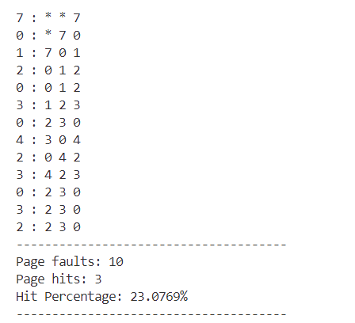

* **Optimal Page Replacement**

**Code:**

 void OPT(vector<int> &reference_string, int num_frames)

    {

        int misses = 0;

        int hits = 0;

        vector<int> frames(num_frames, INT_MAX);

        vector<int> indices(num_frames, INT_MAX);

        cout << endl;

        for (int i = 0; i < reference_string.size(); i++)

        {

            int idx = search(frames, 0, reference_string[i]);

            if (idx == INT_MAX)

            {

                frames.erase(frames.begin() + maxValueIndex(indices));

                indices.erase(indices.begin() + maxValueIndex(indices));

                frames.push_back(reference_string[i]);

                indices.push_back(search(reference_string, i + 1, reference_string[i]));

                misses++;

            }

            else

            {

                indices[idx] = search(reference_string, i + 1, reference_string[i]);

                hits++;

            }

            print_frame(frames, reference_string[i]);

        }

        print_statistics_faults(misses, hits);

    }

**Output:**

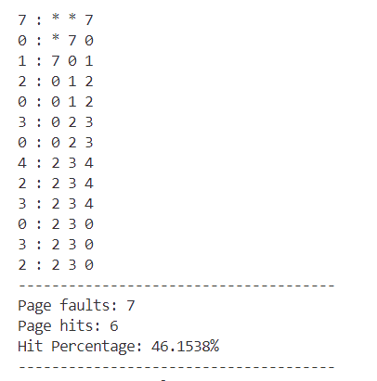

* **LRU Page Replacement**

**Code:**

void LRU(vector<int> reference_string, int num_of_frames)

{

    int misses = 0;

    int hits = 0;

    vector<int> frames(num_of_frames, INT_MAX);

    cout << endl;

    for (int i = 0; i < reference_string.size(); i++)

    {

        int idx = search(frames, 0, reference_string[i]);

        if (idx == INT_MAX)

        {

            frames.erase(frames.begin());

            frames.push_back(reference_string[i]);

            misses++;

        }

        else

        {

            int temp = frames[idx];

            frames.erase(frames.begin() + idx);

            frames.push_back(temp);

            hits++;

        }

        print_frame(frames, reference_string[i]);

    }

    print_statistics_faults(misses, hits);

}

**Output:**

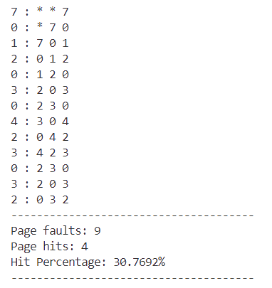

* **MFU Page Replacement**

**Code:**

void MFU(vector<int> &reference_string, int num_frames)

{

    int misses = 0;

    int hits = 0;

    vector<int> frames(num_frames, INT_MAX);

    vector<int> counts(num_frames, INT_MAX);

    cout << endl;

    for (int i = 0; i < reference_string.size(); i++)

    {

        int idx = search(frames, 0, reference_string[i]);

        if (idx == INT_MAX)

        {

            frames.erase(frames.begin() + maxValueIndex(counts));

            counts.erase(counts.begin() + maxValueIndex(counts));

            frames.push_back(reference_string[i]);

            counts.push_back(0);

            misses++;

        }

        else

        {

            counts[idx] = counts[idx] + 1;

            hits++;

        }

        print_frame(frames, reference_string[i]);

    }

    print_statistics_faults(misses, hits);

}

**Output:**

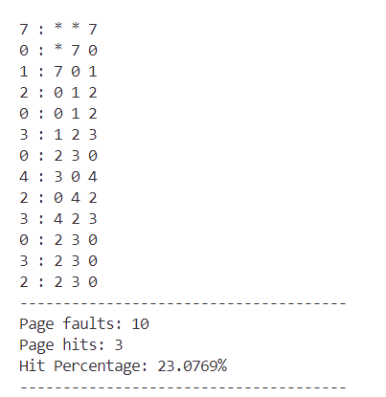

* **LFU Page Replacement**

**Code:**

void LFU(vector<int> &reference_string, int num_frames)

{

    int misses = 0;

    int hits = 0;

    vector<int> frames(num_frames, INT_MAX);

    vector<int> counts(num_frames, INT_MIN);

    cout << endl;

    for (int i = 0; i < reference_string.size(); i++)

    {

        int idx = search(frames, 0, reference_string[i]);

        if (idx == INT_MAX)

        {

            frames.erase(frames.begin() + minValueIndex(counts));

            counts.erase(counts.begin() + minValueIndex(counts));

            frames.push_back(reference_string[i]);

            counts.push_back(0);

            misses++;

        }

        else

        {

            counts[idx] = counts[idx] + 1;

            hits++;

        }

        print_frame(frames, reference_string[i]);

    }

    print_statistics_faults(misses, hits);

}

**Output:**

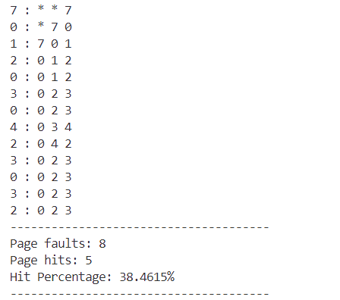

**Practical:- 14**

**WRITE C++ PROGRAMS TO IMPLEMENT DISK SCHEDULING ALGORITHM:**

* **FCFS**
* **SSTF**
* **SCAN**
* **C-SCAN**
* **LOOK**
* **C-LOOK**
* **FCFS**

**Code:**

pair<int, vector<int>> fcfs(vector<pair<int, bool>> &requests, int initialPosition)

{

    vector<int> seekSequence;

    int distance = 0;

    for (int i = 0; i < requests.size(); i++)

    {

        int d = abs(initialPosition - requests[i].first);

        initialPosition = requests[i].first;

        distance += d;

        requests[i].second = true;

        seekSequence.push_back(requests[i].first);

    }

    return {distance, seekSequence};

}

**Output:**

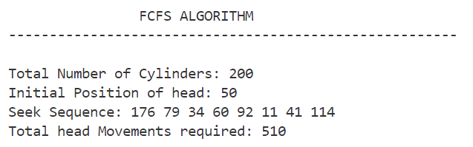

* **SSTF**

**Code:**

pair<int, vector<int>> sstf(vector<pair<int, bool>> requests, int initialPosition)

{

    vector<int> seekSequence;

    int distance = 0;

    int pos = initialPosition;

    while (!requests.empty())

    {

        int minDist = INT_MAX;

        int minIndex = -1;

        for (int i = 0; i < requests.size(); i++)

        {

            int d = abs(pos - requests[i].first);

            if (d < minDist)

            {

                minDist = d;

                minIndex = i;

            }

        }

        pos = requests[minIndex].first;

        distance += minDist;

        seekSequence.push_back(requests[minIndex].first);

        requests.erase(requests.begin() + minIndex);

    }

    return {distance, seekSequence};

}

**Output:**

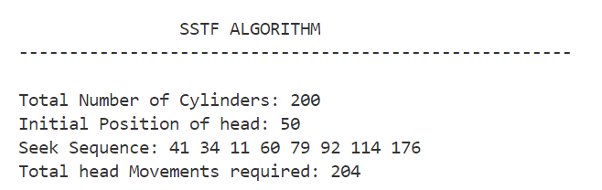

* **SCAN**

**Code:**

pair<int, vector<int>> scan(vector<pair<int, bool>> &requests, int initialPosition, bool direction, int no_of_cylinders)

{

    sort(requests.begin(), requests.end());

    int distance = 0;

    vector<int> seekSequence;

    int pos = initialPosition;

    int idx = -1;

    for (int i = 0; i < requests.size(); i++)

    {

        if (requests[i].first < initialPosition && requests[i + 1].first > initialPosition)

        {

            idx = i + 1;

            break;

        }

    }

    if (direction)

    {

        for (int i = idx; i < requests.size(); i++)

        {

            int d = abs(pos - requests[i].first);

            pos = requests[i].first;

            distance += d;

            requests[i].second = true;

            seekSequence.push_back(requests[i].first);

        }

        distance += (no_of_cylinders - 1) - requests.back().first;

        pos = no_of_cylinders - 1;

        for (int i = requests.size() - 1; i >= 0; i--)

        {

            if (!requests[i].second)

            {

                int d = abs(pos - requests[i].first);

                pos = requests[i].first;

                distance += d;

                requests[i].second = true;

                seekSequence.push_back(requests[i].first);

            }

        }

    }

    else

    {

        for (int i = idx - 1; i >= 0; i--)

        {

            int d = abs(pos - requests[i].first);

            pos = requests[i].first;

            distance += d;

            requests[i].second = true;

            seekSequence.push_back(requests[i].first);

        }

        distance += requests.front().first;

        pos = 0;

        for (int i = 0; i < requests.size(); i++)

        {

            if (!requests[i].second)

            {

                int d = abs(pos - requests[i].first);

                pos = requests[i].first;

                distance += d;

                requests[i].second = true;

                seekSequence.push_back(requests[i].first);

            }

        }

    }

    return {distance, seekSequence};

}

**Output:**

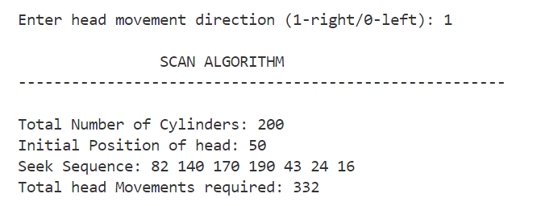

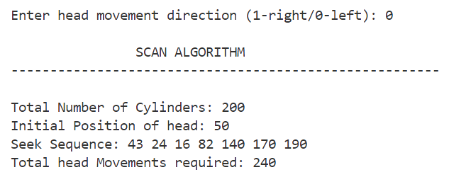

* **C-SCAN**

**Code:**

pair<int, vector<int>> cscan(vector<pair<int, bool>> &requests, int initialPosition, bool direction, int no_of_cylinders)

{

    sort(requests.begin(), requests.end());

    int distance = 0;

    vector<int> seekSequence;

    int pos = initialPosition;

    int idx = -1;

    for (int i = 0; i < requests.size(); i++)

    {

        if (requests[i].first < initialPosition && requests[i + 1].first > initialPosition)

        {

            idx = i + 1;

            break;

        }

    }

    if (direction)

    {

        for (int i = idx; i < requests.size(); i++)

        {

            int d = abs(pos - requests[i].first);

            pos = requests[i].first;

            distance += d;

            requests[i].second = true;

            seekSequence.push_back(requests[i].first);

        }

        distance += (no_of_cylinders - 1) - requests.back().first;

        pos = 0;

        distance += (no_of_cylinders - 1);

        for (int i = 0; i < requests.size(); i++)

        {

            if (!requests[i].second)

            {

                int d = abs(pos - requests[i].first);

                pos = requests[i].first;

                distance += d;

                requests[i].second = true;

                seekSequence.push_back(requests[i].first);

            }

        }

    }

    else

    {

        for (int i = idx - 1; i >= 0; i--)

        {

            int d = abs(pos - requests[i].first);

            pos = requests[i].first;

            distance += d;

            requests[i].second = true;

            seekSequence.push_back(requests[i].first);

        }

        distance += requests.front().first;

        distance += (no_of_cylinders - 1);

        pos = (no_of_cylinders - 1);

        for (int i = requests.size() - 1; i >= 0; i--)

        {

            if (!requests[i].second)

            {

                int d = abs(pos - requests[i].first);

                pos = requests[i].first;

                distance += d;

                requests[i].second = true;

                seekSequence.push_back(requests[i].first);

            }

        }

    }

    return {distance, seekSequence};

}

**Output:**

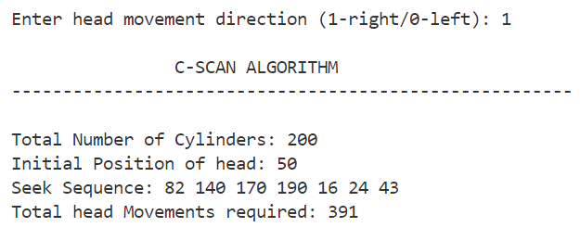

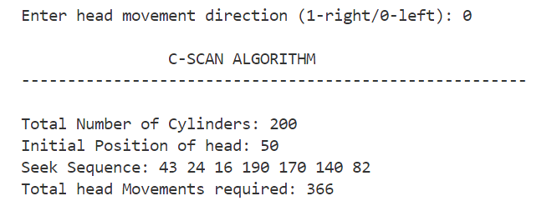

* **LOOK**

**Code:**

pair<int, vector<int>> look(vector<pair<int, bool>> &requests, int initialPosition, bool direction, int no_of_cylinders)

{

    sort(requests.begin(), requests.end());

    int distance = 0;

    vector<int> seekSequence;

    int pos = initialPosition;

    int idx = -1;

    for (int i = 0; i < requests.size(); i++)

    {

        if (requests[i].first < initialPosition && requests[i + 1].first > initialPosition)

        {

            idx = i + 1;

            break;

        }

    }

    if (direction)

    {

        for (int i = idx; i < requests.size(); i++)

        {

            int d = abs(pos - requests[i].first);

            pos = requests[i].first;

            distance += d;

            requests[i].second = true;

            seekSequence.push_back(requests[i].first);

        }

        pos = requests.back().first;

        for (int i = requests.size() - 1; i >= 0; i--)

        {

            if (!requests[i].second)

            {

                int d = abs(pos - requests[i].first);

                pos = requests[i].first;

                distance += d;

                requests[i].second = true;

                seekSequence.push_back(requests[i].first);

            }

        }

    }

    else

    {

        for (int i = idx - 1; i >= 0; i--)

        {

            int d = abs(pos - requests[i].first);

            pos = requests[i].first;

            distance += d;

            requests[i].second = true;

            seekSequence.push_back(requests[i].first);

        }

        pos = requests.front().first;

        for (int i = 0; i < requests.size(); i++)

        {

            if (!requests[i].second)

            {

                int d = abs(pos - requests[i].first);

                pos = requests[i].first;

                distance += d;

                requests[i].second = true;

                seekSequence.push_back(requests[i].first);

            }

        }

    }

    return {distance, seekSequence};

}

**Output:**

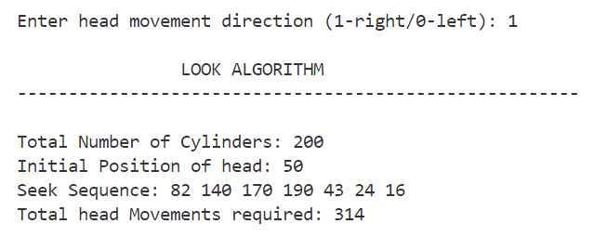

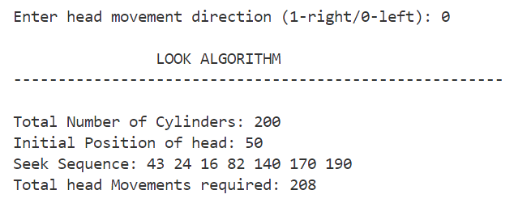

* **C-LOOK**

**Code:**

pair<int, vector<int>> clook(vector<pair<int, bool>> &requests, int initialPosition, bool direction, int no_of_cylinders)

{

    sort(requests.begin(), requests.end());

    int distance = 0;

    int pos = initialPosition;

    vector<int> seekSequence;

    int idx = -1;

    for (int i = 0; i < requests.size(); i++)

    {

        if (requests[i].first < initialPosition && requests[i + 1].first > initialPosition)

        {

            idx = i + 1;

            break;

        }

    }

    if (direction)

    {

        for (int i = idx; i < requests.size(); i++)

        {

            int d = abs(pos - requests[i].first);

            pos = requests[i].first;

            distance += d;

            requests[i].second = true;

            seekSequence.push_back(requests[i].first);

        }

        pos = requests.front().first;

        distance += (requests.back().first - requests.front().first);

        for (int i = 0; i < requests.size(); i++)

        {

            if (!requests[i].second)

            {

                int d = abs(pos - requests[i].first);

                pos = requests[i].first;

                distance += d;

                requests[i].second = true;

                seekSequence.push_back(requests[i].first);

            }

        }

    }

    else

    {

        for (int i = idx - 1; i >= 0; i--)

        {

            int d = abs(pos - requests[i].first);

            pos = requests[i].first;

            distance += d;

            requests[i].second = true;

            seekSequence.push_back(requests[i].first);

        }

        pos = requests.back().first;

        distance += (requests.back().first - requests.front().first);

        for (int i = requests.size() - 1; i >= 0; i--)

        {

            if (!requests[i].second)

            {

                int d = abs(pos - requests[i].first);

                pos = requests[i].first;

                distance += d;

                requests[i].second = true;

                seekSequence.push_back(requests[i].first);

            }

        }

    }

    return {distance, seekSequence};

}

**Output:**

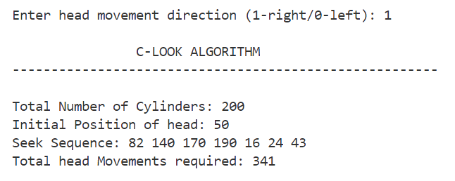

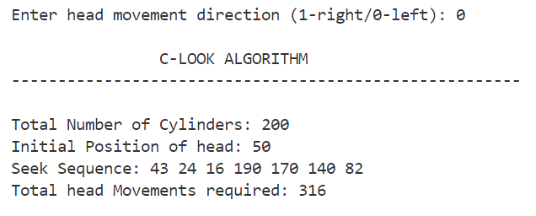

**Practical:- 15**

**WRITE C++ PROGRAMS TO IMPLEMENT THE FOLLOWING MEMORY MANAGEMENT ALGORITHMS (MVT) :**

* **FIRST FIT (FF)**
* **BEST FIT (BF)**
* **WORST FIT (WF)**

class Partition

{

public:

    int id;   // id of partiton

    int size; // size of Partition

    bool alloted;

    vector<int> noOfProc;

    Partition()

    {

        this->size = 0;

        this->id = 0;

        this->alloted = false;

    }

};

class process

{

public:

    int id;

    int memory_required;

    int allocated_Partition;

    bool allocated;

    process()

    {

        this->id = 0;

        this->memory_required = 0;

        this->allocated_Partition = 0;

        this->allocated = false;

    }

};

* **FIRST FIT (FF)**

**Code:**

void FirstFit(vector<Partition> &listPart, vector<process> &listProc)

{

    for (int i = 0; i < listProc.size(); i++)

    {

        for (int j = 0; j < listPart.size(); j++)

        {

            if (listProc[i].memory_required > listPart[j].size)

                continue;

            else

            {

                listProc[i].allocated = true;

                listProc[i].allocated_Partition = listPart[j].id;

                listPart[j].alloted = true;

                listPart[j].size -= listProc[i].memory_required;

                listPart[j].noOfProc.push_back(listProc[i].id);

                break;

            }

        }

    }

}

**Output:**

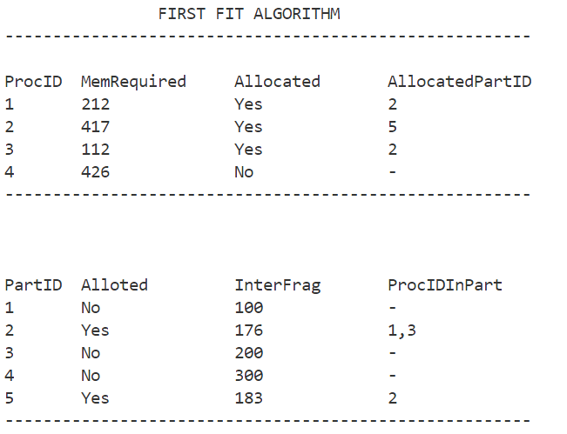

* **BEST FIT (BF)**

**Code:**

void BestFit(vector<Partition> &listPart, vector<process> &listProc)

{

    for (int i = 0; i < listProc.size(); i++)

    {

        vector<int> satisfying_part_idxs; // to store the idx of partitions that can fill the mem requirement of process, and

                                          //  select the partition having min size from it

        for (int j = 0; j < listPart.size(); j++)

        {

            if (listProc[i].memory_required > listPart[j].size)

                continue;

            else

            {

                satisfying_part_idxs.push_back(j); // storing

            }

        }

        if (!satisfying_part_idxs.empty()) // selecting

        {

            int min = INT_MAX;

            int min_idx = -1;

            for (int j = 0; j < satisfying_part_idxs.size(); j++)

            {

                if (listPart[satisfying_part_idxs[j]].size < min)

                {

                    min = listPart[satisfying_part_idxs[j]].size;

                    min_idx = satisfying_part_idxs[j];

                }

            }

            listProc[i].allocated = true;

            listProc[i].allocated_Partition = listPart[min_idx].id;

            listPart[min_idx].alloted = true;

            listPart[min_idx].size -= listProc[i].memory_required;

            listPart[min_idx].noOfProc.push_back(listProc[i].id);

        }

    }

}

**Output:**

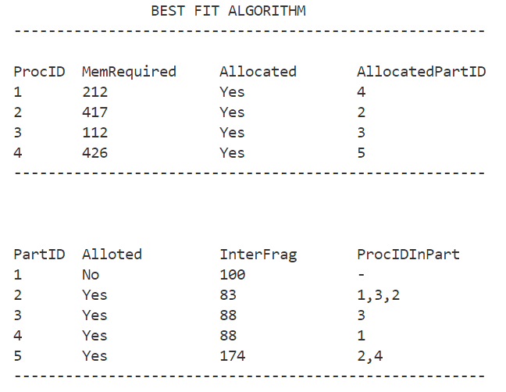

* **WORST FIT (WF)**

**Code:**

void WorstFit(vector<Partition> &listPart, vector<process> &listProc)

{

    for (int i = 0; i < listProc.size(); i++)

    {

        int maxFree_idx = 0;

        for (int j = 1; j < listPart.size(); j++) // finding the index of partition having max size

        {

            if (listPart[j].size > listPart[maxFree_idx].size)

            {

                maxFree_idx = j;

            }

        }

        if (listProc[i].memory_required > listPart[maxFree_idx].size)

            continue;

        else

        {

            listProc[i].allocated = true;

            listProc[i].allocated_Partition = listPart[maxFree_idx].id;

            listPart[maxFree_idx].alloted = true;

            listPart[maxFree_idx].size -= listProc[i].memory_required;

            listPart[maxFree_idx].noOfProc.push_back(listProc[i].id);

        }

    }

}

**Output:**

